

**VIETNAM NATION UNIVERSITY – HO CHI MINH CITY**

**UNIVERSITY OF INFORMATION TECHNOLOGY**

**FACULTY OF** **INFORMATION SYSTEMS**



**FINAL REPORT**

**INFORMATION SYSTEMS ANALYSIS AND DESIGN**

**TRAVEL BOOKING WEBSITE**

# 

Instructors: PhD. Cao Thị Nhạn, M.S. Dương Phi Long

Lê Trịnh Thanh Thúy 19522325

Phạm Minh Quân 19522084

Nguyễn Thị Ngọc Thoại 19522297

Nguyễn Thị Mỹ Thanh 19522240

# **THANK YOU**

During the implementation of the project, the authors always received the help, concern, and enthusiastic comments of teachers, family, and friends. With sincere gratitude, the authors express their gratitude to individuals and organizations who have helped the group in the past.

First of all, the team would like to express their deepest gratitude to the two instructors, PhD. Cao Thi Nhan, and M.S. Duong Phi Long - lecturers of System Analysist and Design, have enthusiastically guided and provided suggestions during the research, implementation, and completion of the course project.

Sincere thanks to all the teachers at the University of Information Technology - Vietnam National University, Ho Chi Minh City in general and the teachers of the Information Systems Department in particular for providing knowledge from a general outline, branch-to-specialty basis, helping the group to have a theoretical basis to carry out this topic.

Finally, the team would like to thank family and friends for their interest and create conditions to help the team complete the project in the best way.

During the implementation of the project, the team applied the knowledge they had been taught and researched and applied new knowledge to the implementation of the project with the desire to complete it almost perfectly. However, with limited time, knowledge, and experience, shortcomings cannot be avoided, so the author team is looking forward to receiving valuable suggestions from the teacher to help the group to supplement and improve. knowledge to better serve future projects as well as practical work.

The authors would like to express their sincere thanks.

**Contents**

**THANK YOU** 1.1-2

**Chapter 1: INTRODUCTION** 1.1-6

**1.1. Introduction** 1.1-6

**1.2. Problems of project** 1.2-6

**1.3. Objectives of the project** 1.3-7

**1.4. Limitations of the study** 1.4-7

**Chapter 2: REQUIREMENT SPECIFICATION** 1.4-8

**2.1.** **Situation survey/ Survey of current situation** 1.4-8

**2.1.1. Interview** 1.4-8

**2.1.2. Survey of the organization/ Current organizational situation** 1.4-12

**2.1.3. Survey of business processes, major activities** 1.4-12

**2.2. Software requirements** 2.2-14

**2.2.1. Functional requirements** 2.2-14

**2.2.2. Non-functional requirements** 2.2-15

**Chapter 3: ANALYSIS AND DESIGN** 2.2-17

**3.1. Use-case Diagram** 3.1-17

**3.1.1. List of actors** 3.1-21

**3.1.2. List of Use-case** 3.1-21

**3.2. Use-case specification and activity diagram** 3.2-22

**3.2.1. Sign up** 3.2-22

**3.2.2. Sign in (for customer)** 3.2-24

**3.2.3. Update profile** 3.2-26

**3.2.4. Search apartment (for customer)** 3.2-28

**3.2.5. Book apartment (for customer)** 3.2-29

**3.2.6. Cancel apartment** 3.2-31

**3.2.7. Give feedback (for customer)** 3.2-32

**3.2.8. Change password (for customer)** 3.2-34

**3.2.9. Sign in (for administrator)** 3.2-36

**3.2.10. Change password (for administrator)** 3.2-38

**3.2.11. Search apartment (for administrator)** 3.2-40

**3.2.12. Book apartment (for administrator)** 3.2-41

**3.2.13. Give feedback (for administrator)** 3.2-43

**3.2.14. Manage customers** 3.2-45

**3.2.15. Manage apartments** 3.2-52

**3.2.16. Manage employees** 3.2-60

**3.2.17. Manage invoices** 3.2-67

**3.2.18. Manage feedback** 3.2-72

**3.2.19.** **Apartment booking statistics** 3.2-76

**3.3. Sequence Diagram and Class Diagram** 3.3-78

**3.3.1. Sign up** 3.3-78

**3.3.2. Sign in (for customer)** 3.3-79

**3.3.3. Update profile** 3.3-81

**3.3.4. Search apartment (for customer)** 3.3-82

**3.3.5. Book apartment (for customer)** 3.3-83

**3.3.6. Cancel apartment** 3.3-84

**3.3.7. Give feedback (for customer)** 3.3-85

**3.3.8. Change password (for customer)** 3.3-87

**3.3.9. Sign in (for administrator)** 3.3-88

**3.3.10. Change password (for administrator)** 3.3-89

**3.3.11. Search apartment (for administrator)** 3.3-90

**3.3.12. Book apartment (for administrator)** 3.3-91

**3.3.13. Give feedback (for administrator)** 3.3-92

**3.3.14. Manage customers** 3.3-94

**3.3.15. Manage apartments** 3.3-99

**3.3.16. Manage employees** 3.3-103

**3.3.17. Manage invoices** 3.3-107

**3.3.18. Manage feedback** 3.3-110

**3.3.19.** **Apartment booking statistics** 3.3-112

**3.4. Class Diagram and Entity class diagram** 3.4-114

**3.4.1. Customer overview class diagram** 3.4-114

**3.4.2. Administrator overview class diagram** 3.4-115

**3.4.3. Entity class diagram** 3.4-115

**3.4.4. Class diagram specification** 3.4-115

**3.5. State Diagram** 3.5-124

**3.5.1. Invoice** 3.5-124

**3.6.** **Mapping to Relational Model from Entity class diagram** 3.6-125

**Chapter 4: IMPLEMENTATION AND TESTING** 3.6-126

**4.1. Introduction to the implementation environment** 4.1-126

**4.1.1. Development environment** 4.1-126

**4.1.2. Deployment environment** 4.1-126

**4.2. User Interface** 4.2-127

**4.2.1. Login page** 4.2-127

**4.2.2. Home page** 4.2-128

**4.2.3. Apartment information page** 4.2-129

**4.2.4. Booking apartment page** 4.2-130

**4.2.5. Change password page** 4.2-131

**4.2.6. Customer interface** 4.2-132

**4.2.7. Admin interface** 4.2-134

**Chapter 5: CONCLUSION** 4.2-138

**5.1. Project achievement** 5.1-138

**5.2. Limitations** 5.2-138

**5.3. Development direction** 5.3-138

# **Chapter 1: INTRODUCTION**

## **Introduction**

In modern society, human life is progressively improved. People have to work a lot every single day, which means they have less time for entertainment. According to a 2013 study, more than 80% of Americans, who were surveyed, noticed significant drops in stress just after a day or two of traveling, meaning that apartmentism is one of the best ways that helps people suffering all the stress and pressure from work. The big problem is people have to come to the travel agency office to book a apartment and there’s tons of paperwork for the employees if they want to check any pieces of information of a specific apartmentist.

Therefore, the main purpose is to build a system such as the “Apartment Management System” to improve the aforementioned performance issue, which is a crucial thing right now. The system can be used for both travel agencies and employees.

For travel agencies, the system helps to manage the sales process and keep records of apartmentists, suppliers, and travel agents. Increasing sales and employees can spend time on more useful tasks and focus on providing added value.

For apartmentists, the system helps to save several times and money by displaying attractive apartmentist places, allowing them to make reservations anytime, anywhere simply and efficiently.

## **Problems of project**

In the traditional way, the apartmentists need to visit the travel agency office to book a apartment or contact through phone call. It involves a lot of manual paperwork, and apartmentists need to stay in the queue for a long time. Nowadays, most of the travel agencies have been applying technology to management but there still is an inadequate amount of information and advice to agencies and apartmentists about apartment plans. We need a system that can act as a middleman providing a connection between apartmentists and agents through the Internet, giving a variety of travel attractions that can surely match all apartmentists priorities,...

## **Objectives of the project**

* Developing a system that manages the process and activities of a travel agency and apartmentist details.
* Designing a system using which one can perform all operations related to traveling and sightseeing.

## **Limitations of the study**

* Project service scope table

|  |  |  |
| --- | --- | --- |
| No. | Service | Within the project scope or not? |
| 1 | Manage employees | YES |
| 2 | Manage apartmentist attraction information | YES |
| 3 | Manage customer | YES |
| 4 | Manage feedback | YES |
| 5 | Manage invoices | YES |
| 6 | Payment bill service | NO |
| 7 | Apartment booking | YES |
| 8 | Provide feedback mechanism for apartmentist | YES |
| 9 | Manage accompanied services | NO |
| 10 | Pay bills online | NO |

* Project data scope table

|  |  |  |
| --- | --- | --- |
| No. | Data | Within the project scope or not? |
| 1 | Employee data | YES |
| 2 | Customer data | YES |
| 3 | Apartmentist attraction data | YES |
| 4 | Feedback data | YES |
| 5 | Invoice data | YES |

# **Chapter 2: REQUIREMENT SPECIFICATION**



## **Situation survey/ Survey of current situation**

### **Interview**

|  |  |  |  |  |
| --- | --- | --- | --- | --- |
| **Overview of the interview plan**  System: Travel booking website  Founder: Nguyen Thi My Thanh - Nguyen Thi Ngoc Thoai  Date established: 13/10/2021 | | | | |
| **No.** | **Topic** | **Request** | **Start date** | **End date** |
| 1 | Apartment management | Understand the detailed of apartment information | 13/10/2021 | 13/10/2021 |
| 2 | Marketing | Understand the detailed of marketing information | 13/10/2021 | 13/10/2021 |
| 3 | Customer management | Understand customer information | 13/10/2021 | 13/10/2021 |
| 4 | Process of booking | Understand the booking service  process | 13/10/2021 | 13/10/2021 |
| 5 | Customer service | Services to create comfort for customers | 13/10/2021 | 13/10/2021 |
| 6 | Process of set schedule (from booking to start) | Know the schedule information | 13/10/2021 | 13/10/2021 |

|  |  |
| --- | --- |
| **Interview plan table** | |
| System: Travel booking website | |
| Interviewees: Vo Huynh Nhu | Analyst: Nguyen Thi My Thanh –      Nguyen Thi Ngoc Thoai |
| Palce: Cong ty Co phan ĐT TM DV Du lich Đat Viet | Start: 8h, on Wednesday, October 13, 2021  End: 11h, on Wednesday, October 13, 2021 |
| Details of the interview   * Introduce * Overview of the system * Overview of the interview: * Topic 1: Apartment management * Topic 2: Marketing * Topic 3: Customer management * Topic 4: Process of booking * Topic 5: Customer service * Topic 6: Process of set schedule (from booking to start) | Estimated time  – 5 minutes.  – 20 minutes.  – 3 hours. |
| Overview |  |
| Unexpected occurrence |  |

|  |  |  |
| --- | --- | --- |
| **QUESTIONNAIRE** | | |
| **Question** | | **Record** |
| Topic 1 | *Question 1:*  What has the company done so that customers can view information conveniently? | We use the company's website to post available apartments, customers can visit all the company's apartments there. |
| *Question 2:*  What details were described in the apartment? | After clicking on the apartment, it will display the apartment description, the highlights of the trip, the best time to make the trip... |
| *Question 3:*  Does the company research and update more apartments to suit the needs of customers? | Currently there are only a fixed number of apartments, but will research and develop in the future |
| Topic 2 | *Question 1:*  How did the company advertise the apartment? | We advertise apartments on highly visited websites, on YouTube and Facebook. |
| *Question 2:*  What is the most effective way to advertise the apartment that the company has done? | We advertised the apartment on Facebook and created a game. Players share interesting stories during the trip, and that post gets a lot of attention. The number of apartments booked after that was twice as high as usuall. |
| Topic  3 | *Question 1:*  What are the requirements for customers to create an account? | To create an account, customers need phone number, email, name and gender. |
| *Question 2:*  Can customers edit account information? | The correction of personal information is an obvious must, and the confidentiality of information. |
| *Question 3:*  Is the customer's apartment history saved on the account? | We always update the apartments booked by customers in customer information so that customers can view and conveniently check to apply for promotions. |
| Topic 4 | *Question 1:*  Customers want to register an account to book tickets, how to do it? | Customers need a phone number and email to create an account and book tickets, my uncle will contact the customer through that information. |
| *Question 2:*  Is booking a ticket complicated and time consuming? | Just click on the apartment and you will see the ticket table right away, and we have updated your information and the booking form so you just need to choose the date and place of pick up, see the price, and you can order. |
| *Question 3:*  How many payment methods are there? | You can pay by banking or pay 50% in advance when picking up at the departure point and pay in full after the trip. |
| Topic 5 | *Question 1:*  How can customers contact the company? | You can call the company's hotline or contact via Facebook, the staff will answer in a few minutes. |
| *Question 2:*  Does the company provide a shuttle service for customers to the starting point? | The company will use the shuttle bus to pick up customers at registered customers. |
| *Question 3:*  How does the company support the booking process? | In order to make ticket booking as simple as possible for customers, in addition to booking tickets on the web, customers can also call the company's hotline or leave a phone number in the advertisement post, we will actively contact you. |
| Topic 6 | *Question 1:*  Can customers be informed about the departure date, departure location or have to look up information on the web themselves? | We will update the date and time of departure, location as well as the phone number of the person in charge on the website, besides we will actively contact customers a week in advance to inform the schedule. |
| *Question 2:*  The scheduling arranged by the company or chosen by the customer? | The schedule will be chosen by the customer to create comfort for the customer, besides, if the customer does not have time to arrange, we will support the customer to arrange the schedule. |
| *Question 3:*  The schedule of each apartment is fixed or will it change? | The schedule is fixed according to the arrangement that the customer chooses, if there are any changes we will notify and agree with the customer. |

### **Survey of the organization/ Current organizational situation**

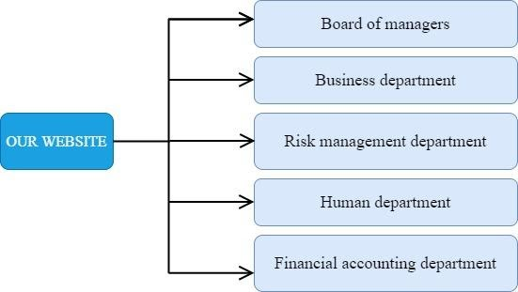

### **Survey of business processes, major activities**

#### Board of Managers

#### Business Department

The guide directs research and development activities for new apartments and improves apartments to meet market needs. Promote the apartment to customers, promote the company's revenue. The sales department has two main functions: marketing and apartment management.

* **Apartment management business**: manage all information about apartmentist destinations, hotels,... research and update about new apartmentist destinations to meet market demand. Including developing new apartments, operating apartmentism organizations.
  + *Developing new apartments process.*
    - Apartmentism market research.
    - Suggest new places (or schedules).
    - Start execution strategy.
  + *Operating apartmentism organizations process.*
    - Arrange plans for apartment guide, car, hotel.
    - Manage customer information, location, hotel, schedule.
* **Marketing Business:** Research effective apartment advertising methods to meet customer needs and attract customers.
  + *Promotion process includes.*
    - Proposing a suitable price policy according to the customer's conditions.
    - Create promotions and discounts for long-term loyal customers.
    - Promotion and marketing bring the apartment closer to customers.
  + *Customer service process.*
    - Develop separate policies for each customer group.
    - Receiving and responding to customer requests.
    - Create a long-term connection and attachment of customers with travel services.

#### Risk Management

Accurately identify risks and offer solutions to bring satisfaction to customers.

* *Risk identification process.*
  + Identify possible risks before and during travel.
  + Propose emergency remedial methods to effectively deal with risks.
  + Cooperate with the marketing department to offer customer retention promotions after risk.

#### Human Department

Business human resource management: monitoring the activities of all employees, including employee information management processes, employee performance management.

* *Employee information management process.*
  + Recruitment.
  + Enter employee information.
  + Update employee information.
* *Employee management process.*
  + Employee's date, time, and activity history.
  + Periodic reports on employee activities.

#### Financial accounting Department

Manage income and expenses and also the flow of money and direct the company's travel business.

* *Financial analysis process.*
  + Create budgets and financial records.
  + Analyze the financial effectiveness of apartment policies as well as promotions.
  + Cooperate with apartment management to create highly profitable apartments.
  + Help set a budget.
  + Cost analysis of apartment building strategies.
  + Help to evaluate the performance of apartments.
  + Help prepare financial statements.
  + Protect assets through internal control.
  + Manage and control the less booked apartments.
  + Financial statements.



## **Software requirements**



### **Functional requirements**

|  |  |
| --- | --- |
| **Functional requirements type** | **Explain** |
| Data storage | Storage is the most basic and necessary for every management system, in this case, is Apartmentism management system. The way that database is being set up helps it be easier to manage and more conducive to operating the system. In order to ensure the storage of the system, we need to store information, which is represented as below:   * Customer information: full name, phone number, email, gender, date of birth, phone number, address, username login ID, password. * Apartment information: apartment’s ID, apartment’s name, location, description, price. * Employee information: full name, phone number, email, gender, date of birth, phone number, address, username login ID, password. * Invoice information: apartment’s ID, customer’s ID, date of departure, date of arrival, total price. |
| Lookup/Search | * Search apartments by entering apartments’ keywords such as apartment’s name. * Search employees by entering employees’ ID or full name. * Search customers by entering customers’ ID or full name. * Search invoices by entering invoice’ ID. |
| Calculation | After booking the apartment, the system calculates the total fee based on the total days (according to date of departure, date of arrival) and apartment’s name. |

### **Non-functional requirements**

|  |  |
| --- | --- |
| **Non-functional requirements type** | **Explain** |
| Convenience | The system is user-friendly, easy-to-use and provides a convenient, intuitive interface. |
| Operational | * The system is a web-based interface and can be able to work on any web browser. * It's simple to maintain, upgrade, and develop the system. |
| Performance | * The system should be available for use 24 hours per day, 365 days per year. * The maximum amount of time it takes to update and upgrade the system is one day. |
| Security | * Employees can only have permission to see others management information when they are already logged in. * Customers can only view, search apartment, and edit their personal information. |
| Cultural and Political | * Personal information is protected under applicable law. * Programmers have the right to customize the interface and language to suit the user. |

# **Chapter 3: ANALYSIS AND DESIGN**



## **Use-case Diagram**

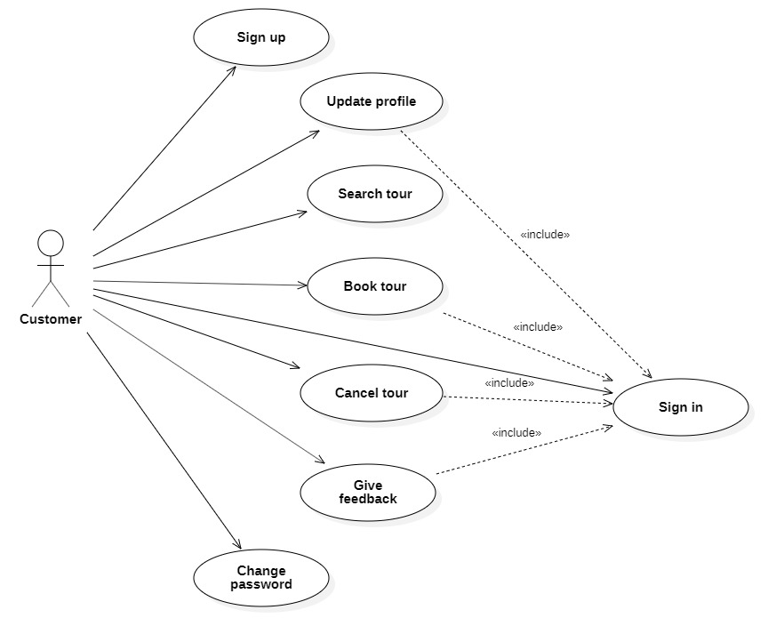



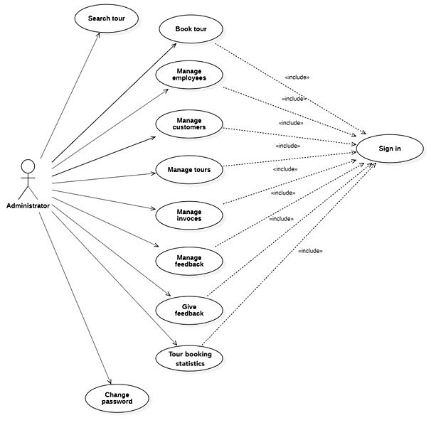



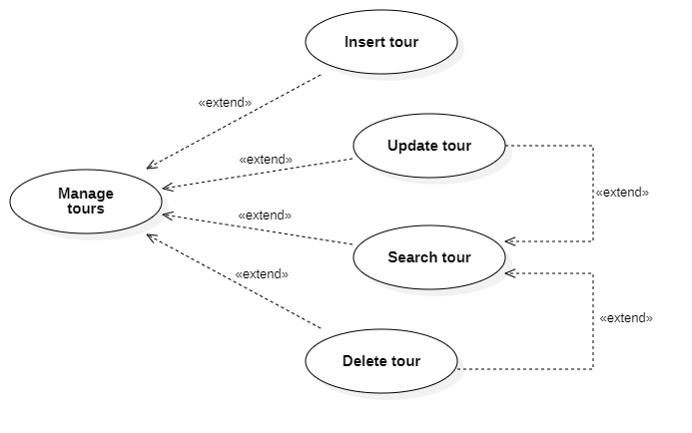

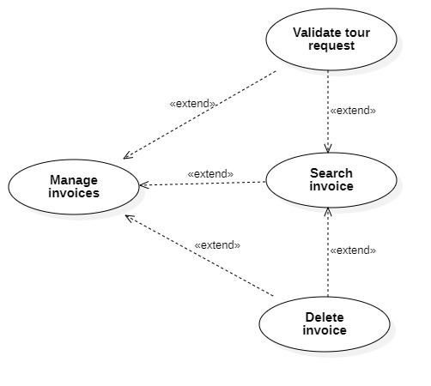

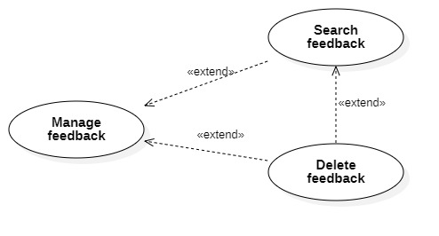



### **List of actors**

|  |  |
| --- | --- |
| **Actor** | **Description** |
| Administrator | Employees who manage the whole apartmentism system. |
| Customer | Customers who register to use available system’s services |

### **List of Use-case**

|  |  |  |
| --- | --- | --- |
| **Role** | **Use-case** | **Description** |
| Administrator’s role | Sign in | Sign in to manage the system. After the user logs in, the system will switch to the admin home interface. |
| Change password | Allow admin to change the old password with a new one. |
| Search apartment | Allow admin to search apartment’s information. |
| Book apartment | Allow admin to book apartments after signing in. |
| Give feedback | Admin can give feedback for a specific apartment. |
| Manage apartments | Allow admin to perform the apartment management functions such as insert, update, delete, search apartment information. |
| Manage invoices | Allow admin to perform the invoice management functions such as search, delete invoice information and validate apartment booking invoice. |
| Manage feedback | Allow admin to perform the feedback management functions such as search and delete feedback information. |
| Analysis Revenue | Analysis revenue according to quantity of booking specific apartment in a month. |
| Customer’s role | Sign up | Sign up for membership. |
| Sign in | Sign in for using services. After the user logs in, the system will switch to the customer home interface. |
| Search  apartment | Allow the customer to search apartment’s information. |
| Book apartment | Allow the customer to book apartments after signing in. |

## **Use-case specification and activity diagram**



### **Sign up**

|  |  |
| --- | --- |
| Use case name | Sign up. |
| Description | Customers create an account for booking apartment. |
| Trigger | Customers click the button “Sign Up”. |
| Pre-condition | Customers’ devices must connect to the Internet. |
| Post-condition | Customers get a notification about sign-up successful. |
| Basic flow | 1. The system displays the sign-up page.  2. Customers enter information such as username, full name, password, … and click Submit button.  3. The system validates customers’s entered information in the correct format.  4. The system validates customers’s information which is unique in the database.  5. The system stores customers’s information in the database.  6. The system notifies customers that account created; customers can sign in by using this account. |
| Alternative flow | 3a. The system displays invalid information due to the wrong format.  Use-case continues at step 3.  4a. The system displays invalid information when customers’ information has already been existed in the database.  Use-case continues at step 3. |
| Exception flow |  |

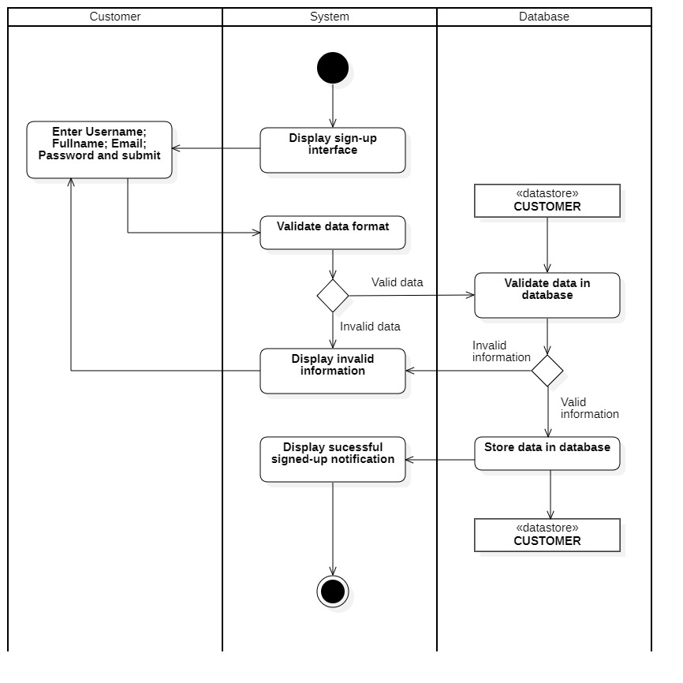

### **Sign in (for customer)**

|  |  |
| --- | --- |
| Use case name | Sign in (for customer). |
| Description | Customers use an existing account to sign in to the system. |
| Trigger | Customers click the button “Sign In”. |
| Pre-condition | Customers’ devices must connect to the Internet.  Customers’ accounts existed in the database. |
| Post-condition | The system loads to the home page and customers can now view all the information details. |
| Basic flow | 1. The system displays the sign-in page.  2. Customers enter username & password and click submit.  3. The system validates username & password in the correct format.  4. The system validates customer’s input data with existing account data in the database.  5. The system redirects to the home interface. |
| Alternative flow | 3a. The system displays invalid information due to the wrong format.  Use-case continues at step 3.  4a. The system displays invalid information when customer’s account information does not match with existing account information in the database.  Use-case continues at step 3. |
| Exception flow |  |

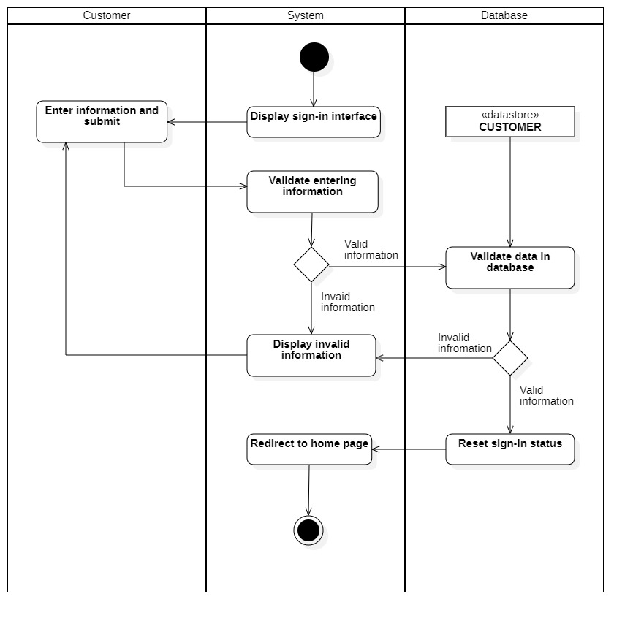

### **Search apartment (for customer)**

|  |  |
| --- | --- |
| Use case name | Search apartment (for customer). |
| Description | Customers search a apartment according to some keywords. |
| Trigger |  |
| Pre-condition | Customers’ devices must connect to the Internet. |
| Post-condition | Customers get detailed information about a specific apartment. |
| Basic flow | 1. The system displays home page with data loaded from the database.  2. Customers enter keywords on the text field then click the “Search” button.  3. The system processes search request.  4. The system queries a specific apartment related to keywords.  5. The system display result about apartment’s information. |
| Alternative flow | 4a. The system displays empty results when the system can’t find a correct apartment related to keywords. |
| Exception flow |  |

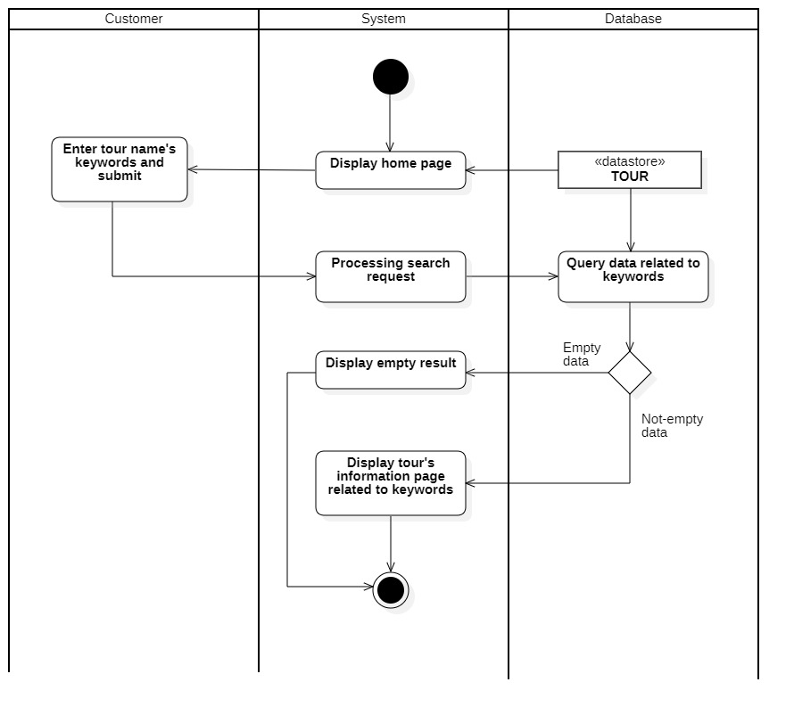

### **Book apartment (for customer)**

|  |  |
| --- | --- |
| Use case name | Book apartment (for customer). |
| Description | Customers book apartment for their personal needed. |
| Trigger | Customers select a specific apartment on the home page. |
| Pre-condition | Customer’s devices must connect to the Internet. Customers’s must log in to the system. |
| Post-condition | Customers book apartments successfully.  Customers’ apartment booking information is stored in the database. |
| Basic flow | 1. The system displays home page with data loaded from the database.  2. Customers select a specific apartment.  3. The system processes search request.  4. The system queries apartment’s information.  5. The system displays apartment’s information.  6. Customers enter travel destination, start and end date,… and click Submit button.  7. The system stores booking information in the database.  8. The system displays a successful booking message to customers. |
| Alternative flow |  |
| Exception flow |  |

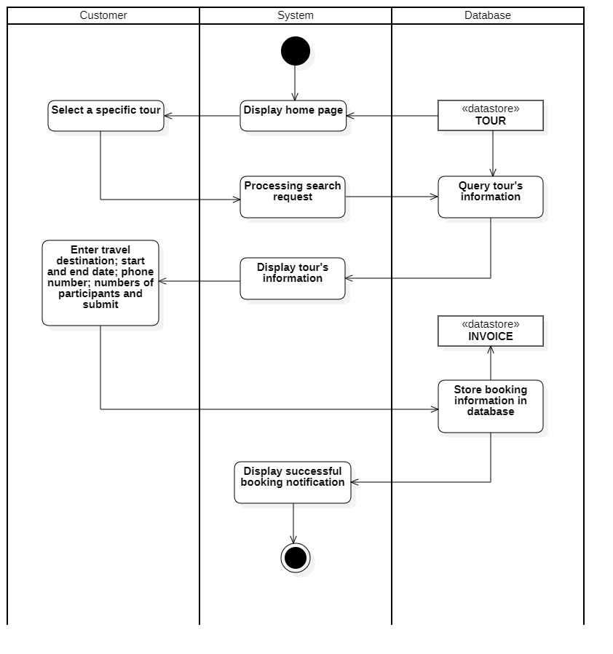

### **Sign in (for administrator)**

|  |  |
| --- | --- |
| Use case name | Sign in (for administrator). |
| Description | Administrator uses an existing account to sign in to the system. |
| Trigger | Administrator clicks the button “Sign In”. |
| Pre-condition | Administrator’s device must connect to the Internet.  Customers’ accounts existed in the database. |
| Post-condition | The system loads to the home page and customers can now view all the information details. |
| Basic flow | 1. The system displays the sign-in page.  2. Administrator enters username & password and click submit.  3. The system validates username & password in the correct format.  4. The system validates administrator’s input data with existing account data in the database.  5. The system redirects to the home interface. |
| Alternative flow | 3a. The system displays invalid information due to the wrong format.  Use-case continues at step 2.  4a. The system displays invalid information when administrator’s account information does not match with existing account information in the database.  Use-case continues at step 2. |
| Exception flow |  |

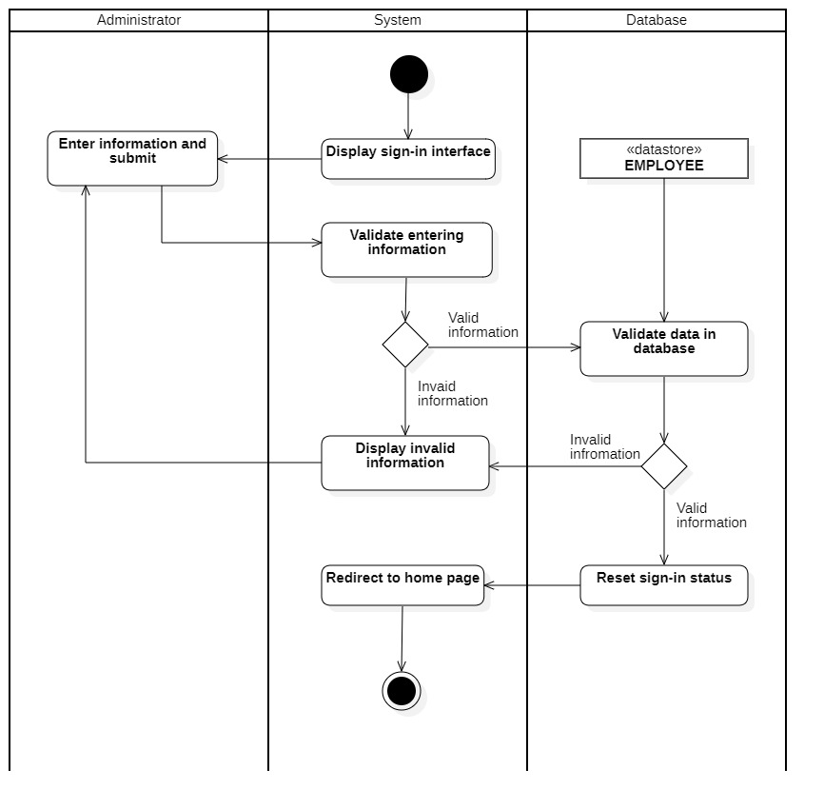

### **Change password (for administrator)**

|  |  |
| --- | --- |
| Use case name | Change password (for customer). |
| Description | Administrator changes password for secure account. |
| Trigger |  |
| Pre-condition | Administrator’s devices must connect to the Internet. |
| Post-condition | Administrator successfully changed password. |
| Basic flow | 1. The system displays change password page.  2. Administrator enters username & old password, new password and click Submit.  3. The system validates username, old password, new password in the correct format.  4. The system validates input data with existing account data in the database.  5. The system updates new password in the database.  6. The system displays a successful change password message to administrator. |
| Alternative flow | 3a. The system displays invalid information due to the wrong format.  Use-case continues at step 2.  4a. The system displays invalid information when username does not match with existing account information in the database.  Use-case continues at step 2. |
| Exception flow |  |

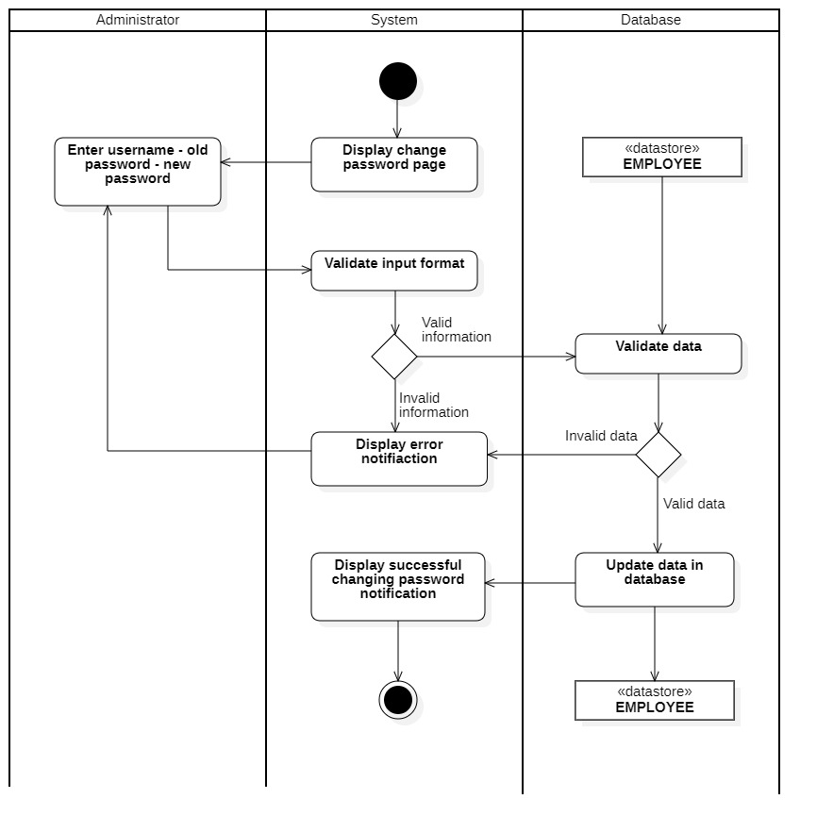

### **Search apartment (for administrator)**

|  |  |
| --- | --- |
| Use case name | Search apartment (for administrator). |
| Description | Administrator searches a apartment according to some keywords. |
| Trigger |  |
| Pre-condition | Administrator’s devices must connect to the Internet. |
| Post-condition | Administrator gets detailed information about a specific apartment. |
| Basic flow | 1. The system displays home page with data loaded from the database.  2. Administrator enters keywords on the text field then click the “Search” button.  3. The system processes search request.  4. The system queries a specific apartment related to keywords.  5. The system display result about apartment’s information. |
| Alternative flow | 4a. The system displays empty results when the system can’t find a correct apartment related to keywords. |
| Exception flow |  |

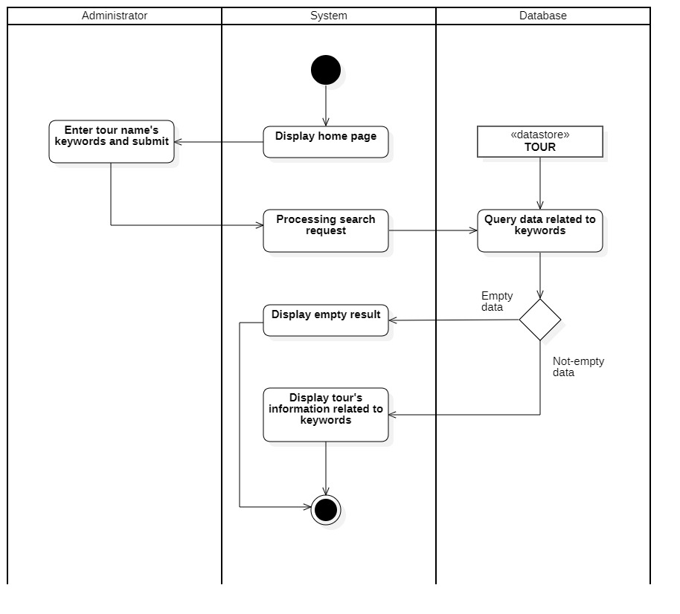

### **Book apartment (for administrator)**

|  |  |
| --- | --- |
| Use case name | Book apartment (for administrator). |
| Description | Administrator books apartment for their personal needed. |
| Trigger | Administrator selects a specific apartment on the home page. |
| Pre-condition | Administrator’s devices must connect to the Internet.  Administrator’s must log in to the system. |
| Post-condition | Administrator books apartments successfully.  Administrator’s apartment booking information is stored in the database. |
| Basic flow | 1. The system displays home page with data loaded from the database.  2. Administrator selects a specific apartment.  3. The system processes search request.  4. The system queries apartment’s information.  5. The system displays apartment’s information.  6. Administrator enters travel destination, start and end date,… and click Submit button.  7. The system stores booking information in the database.  8. The system displays a successful booking message to customers. |
| Alternative flow |  |
| Exception flow |  |

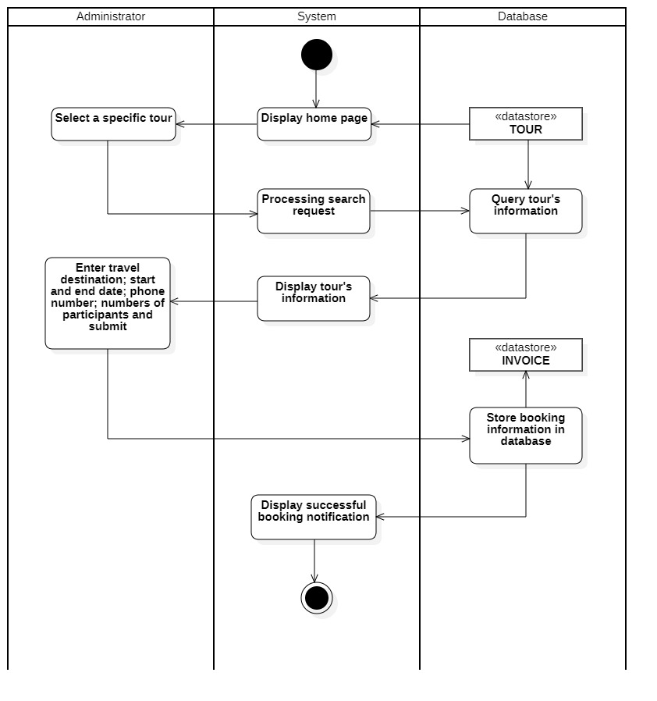

### **Give feedback (for administrator)**

|  |  |
| --- | --- |
| Use case name | Give feedback (for administrator). |
| Description | Administrators give feedback about a specific apartment. |
| Trigger |  |
| Pre-condition | Administrator’s device must connect to the Internet  Administrator must log in to the system. |
| Post-condition | The system displays new feedbacks on the current page |
| Basic flow | 1. The system displays home page with data loaded from the database.  2. Administrator selects a specific apartment that represents on the home page.  3. The system processes search request.  4. The system queries apartment detailed information.  5. The system displays apartment’s information.  6. Administrator enters feedbacks (the system doesn’t require a standard format for a feedback text field).  7. The system inserts feedback into the database.  8. The system displays feedback on the current page. |
| Alternative flow |  |
| Exception flow |  |

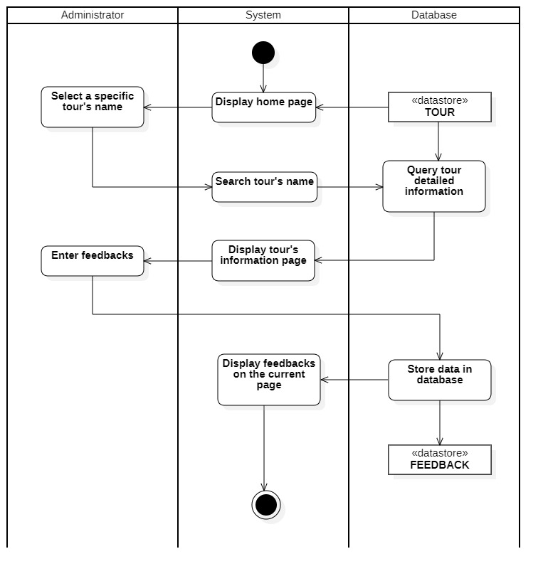

### **Manage apartments**

#### Insert apartment

|  |  |
| --- | --- |
| Use case name | Insert apartment. |
| Description | Administrator can insert a new apartment to the database. |
| Trigger | Administrator clicks the button “Add” at the apartment management page. |
| Pre-condition | Administrator’ device must connect to the Internet.  Server must connect to the database.  Administrator must log in to the system. |
| Post-condition | Show successful inserting message. New apartment’s information is also displayed on the apartment management system. |
| Basic flow | 1. The system displays the apartment management page with data loaded from the database.  2. Administrator clicks the button “Add” at the selected data.  3. The system displays the apartment's information form.  4. Administrator enters apartment's information in the database.  5. The system validates apartment’s information in the correct format.  6. The system validates apartment's information that hadn’t existed in the database.  7. The system inserts apartment's information into the database.  8. The system displays a successful inserting message.  9. The system displays information that has just been added on the apartment information management page. |
| Alternative flow | 5a. The system displays invalid information due to the wrong format.  Use-case continues at step 4.  6a. The system displays invalid information because the information had been existed in the database.  Use-case continues at step 4. |
| Exception flow |  |

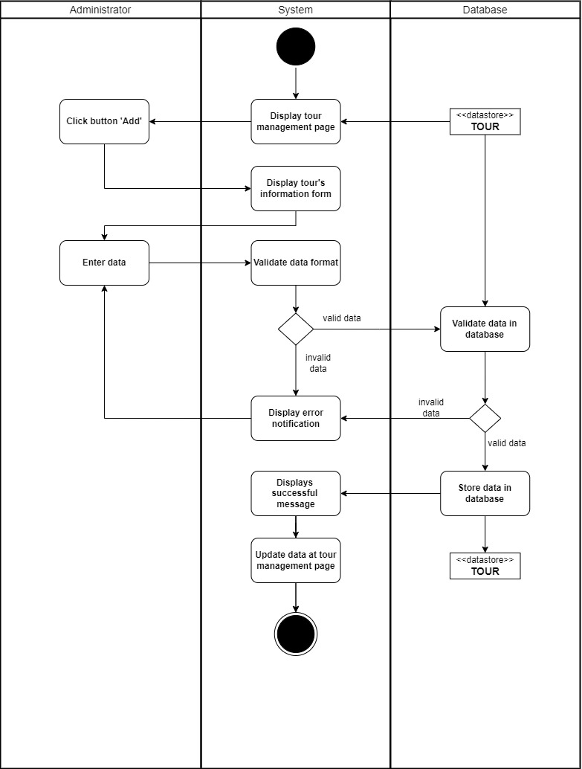

#### Update apartment

|  |  |
| --- | --- |
| Use case name | Update apartment. |
| Description | Administrator can edit information about a apartment. |
| Trigger | Administrator clicks the button “Update” at the apartment management interface. |
| Pre-condition | Administrator’ device must connect to the Internet.  Administrator’s must log in to the system.  Apartment information must be existed in the database before updating. |
| Post-condition | Show update successful message.  Data at the management page is updated (the selected apartment had been updated). |
| Basic flow | 1. The system displays apartment management page with data loaded from the database.  2. Administrator selects update function and name to be updated.  3. Administrator modifies apartment’s information.  4. The system validates apartment’s information in the correct format.  5. The system validates apartment’s information that hadn’t existed in the database.  6. The system updates apartment’s information in the database.  7. The system display new information that has just been updated on the apartment management page. |
| Alternative flow | 4a. The system displays invalid information due to the wrong format.  Use-case continues at step 3.  5a. The system displays invalid information because data has already been in the database.  Use-case continues at step 3. |
| Exception flow |  |

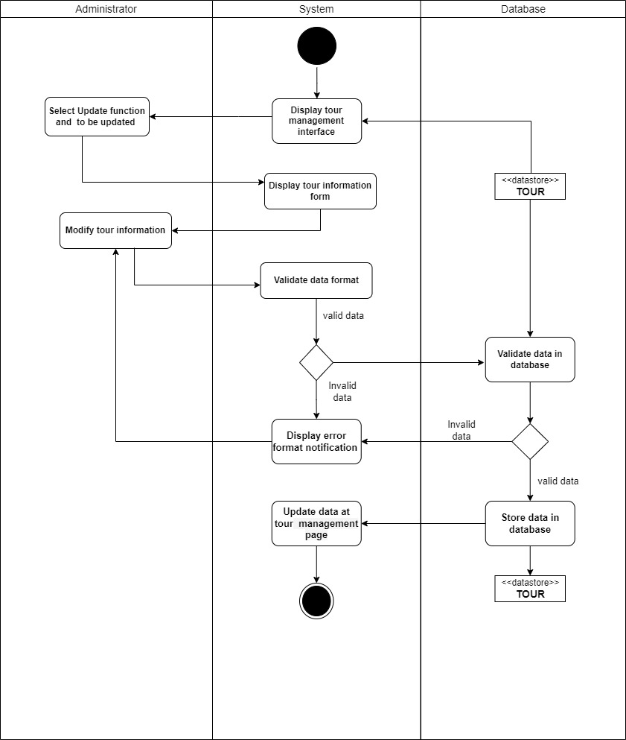

#### Delete apartment

|  |  |
| --- | --- |
| Use case name | Delete apartment. |
| Description | Administrator can delete an existed apartment in the database. |
| Trigger | Administrator clicks the button “Delete” at the customer management interface. |
| Pre-condition | Administrator’s device must connect to the Internet.  Administrator’s must log in to the system.  Apartment information must be existed in the database before deleting. |
| Post-condition | Data at the management page is updated (the selected apartment had been deleted). |
| Basic flow | 1. The system displays apartment management page with data loaded from the database.  2. Administrator selects delete function and name to be deleted.  3. The system processes delete request.  4. The system validates no external data required customer information and selected item existed in the database.  5. The system deletes apartment’s information in the database.  6. The system updates data at apartment management page. |
| Alternative flow | 4a. The system display error notification when there is non-data existing in the database.  Use-case stop. |
| Exception flow |  |

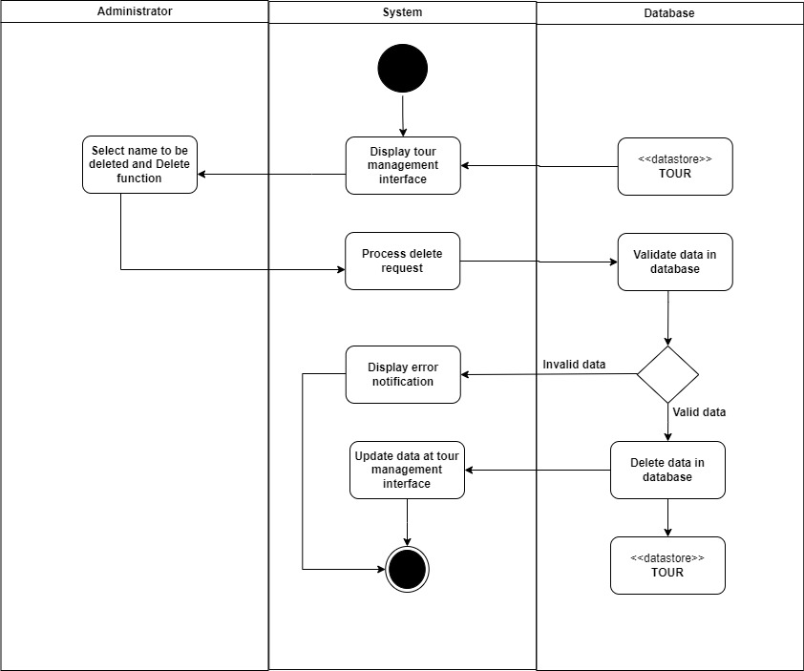

#### Search apartment

|  |  |
| --- | --- |
| Use case name | Search apartment. |
| Description | Administrator searches a apartment information. |
| Trigger | Administrator clicks to button “Manage Apartment” sidebar. |
| Pre-condition | Administrator’ device must connect to the Internet.  Administrator’s must log in to the system. |
| Post-condition | Administrator gets detailed information about an apartment. |
| Basic flow | 1. The system displays apartment management interface with data loaded from the database.  2. Administrator enters apartment’s ID on the text field.  3. The system processes search request.  4. The system queries a apartment related to ID.  5. The system displays result at the apartment management interface. |
| Alternative flow | 4a. The system displays empty results when the system can’t find a correct apartment.  Use-case stop. |
| Exception flow |  |

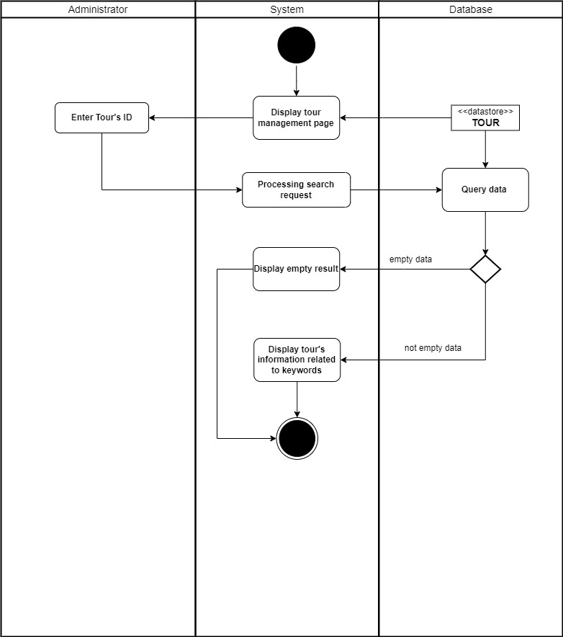

### **Manage invoices**

#### Delete invoice

|  |  |
| --- | --- |
| Use case name | Delete invoice. |
| Description | Administrator can delete an existed invoice in the database. |
| Trigger | Administrator clicks the button “Delete” at the invoice management interface. |
| Pre-condition | Administrator’s device must connect to the Internet.  Administrator’s must log in to the system.  Invoice information must be existed in the database before deleting. |
| Post-condition | Data at the management page is updated (the selected invoice had been deleted). |
| Basic flow | 1. The system displays invoice management page with data loaded from the database.  2. Administrator selects delete function and name to be deleted.  3. The system processes delete request.  4. The system validates no external data required employee information and selected item existed in the database.  5. The system deletes invoice’s information in the database.  6. The system updates data at invoice management page. |
| Alternative flow | 4a. The system display error notification when there is non-data existing in the database.  Use-case stop. |
| Exception flow |  |

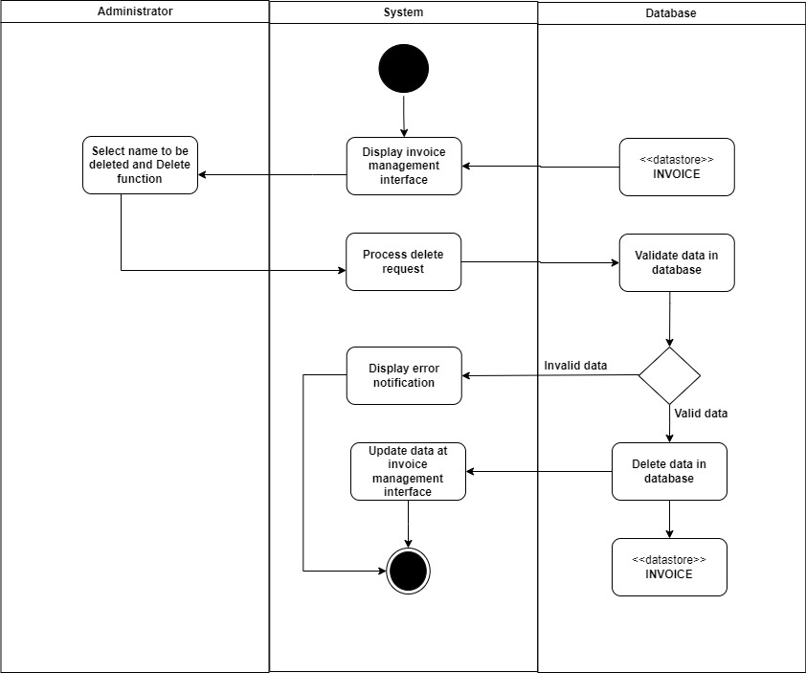

#### Search invoice

|  |  |
| --- | --- |
| Use case name | Search invoice. |
| Description | Administrator searches a invoice information. |
| Trigger | Administrator clicks to button “Manage Invoice” sidebar. |
| Pre-condition | Administrator’s device must connect to the Internet.  Administrator’s must log in to the system. |
| Post-condition | Administrator gets detailed information about an invoice. |
| Basic flow | 1. The system displays invoice management interface with data loaded from the database.  2. Administrator enters invoice’s ID on the text field.  3. The system processes search request.  4. The system queries an invoice related to ID.  5. The system displays result at the invoice management interface. |
| Alternative flow | 4a. The system displays empty results when the system can’t find a correct invoice.  Use-case stop. |
| Exception flow |  |

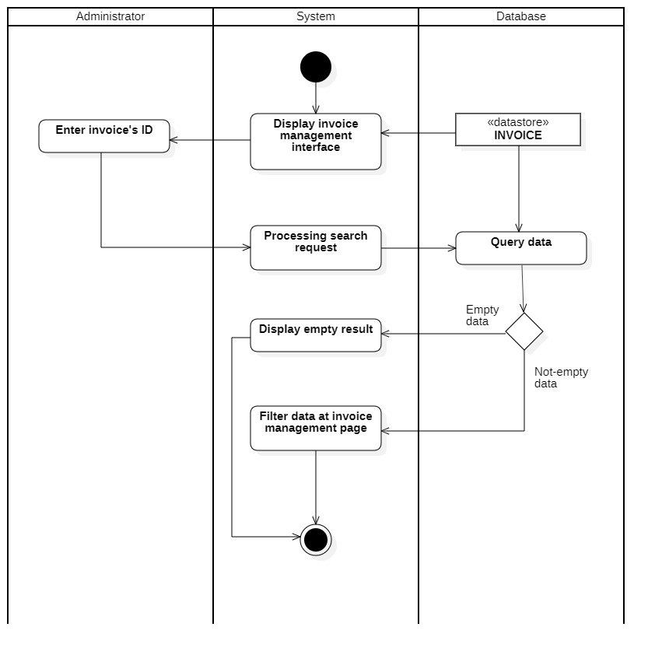

#### Validate apartment booking request

|  |  |
| --- | --- |
| Use case name | Validate apartment booking request. |
| Description | Administrator can modify the status of existing invoices in the database. |
| Trigger | Administrator clicks the button “Cofirm” or “Cancel” at the invoice management interface. |
| Pre-condition | Administrator’s device must connect to the Internet.  Administrator’s must log in to the system.  Invoice information must be existed in the database before validating. |
| Post-condition | The booking status of the invoice on the management page is updated. |
| Basic flow | 1. The system displays invoice management page with data loaded from the database.  2. Administrator chooses option.  2.1. If administrator chooses “Confirm” button.  2.1.1. The systems processes confirm request.  2.1.2. The system will set the status of the invoice to “1”.  2.1.3. The system updates the new status on the management page.  2.2. If administrator chooses “Cancel” button.  2.2.1. The systems processes cancel request.  2.2.2. The system will set the status of the invoice to “0”.  2.2.3. The system updates the new status on the management page. |
| Alternative flow |  |
| Exception flow |  |

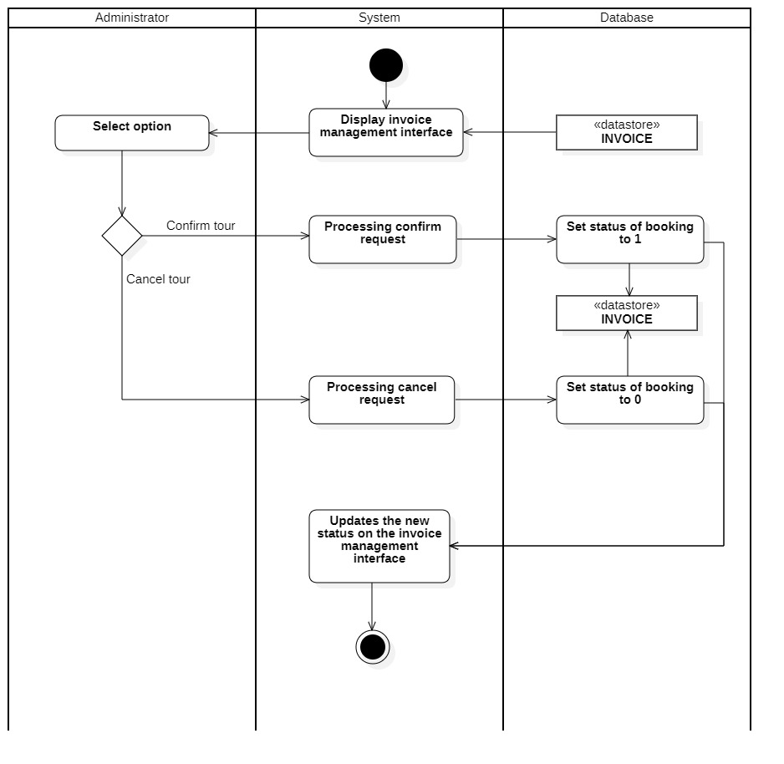

### **Manage feedback**

#### Delete feedback

|  |  |
| --- | --- |
| Use case name | Delete feedback. |
| Description | Administrator can delete an existed feedback in the database. |
| Trigger | Administrator clicks the button “Delete” at the feedback management interface. |
| Pre-condition | Administrator’s device must connect to the Internet.  Administrator’s must log in to the system.  Feedback information must be existed in the database before deleting. |
| Post-condition | Data at the management page is updated (the selected feedback had been deleted). |
| Basic flow | 1. The system displays feedback management page with data loaded from the database.  2. Administrator selects delete function and name to be deleted.  3. The system processes delete request.  4. The system validates no external data required employee information and selected item existed in the database.  5. The system deletes feedback’s information in the database.  6. The system updates data at feedback management page. |
| Alternative flow | 4a. The system display error notification when there is non-data existing in the database.  Use-case stop. |
| Exception flow |  |

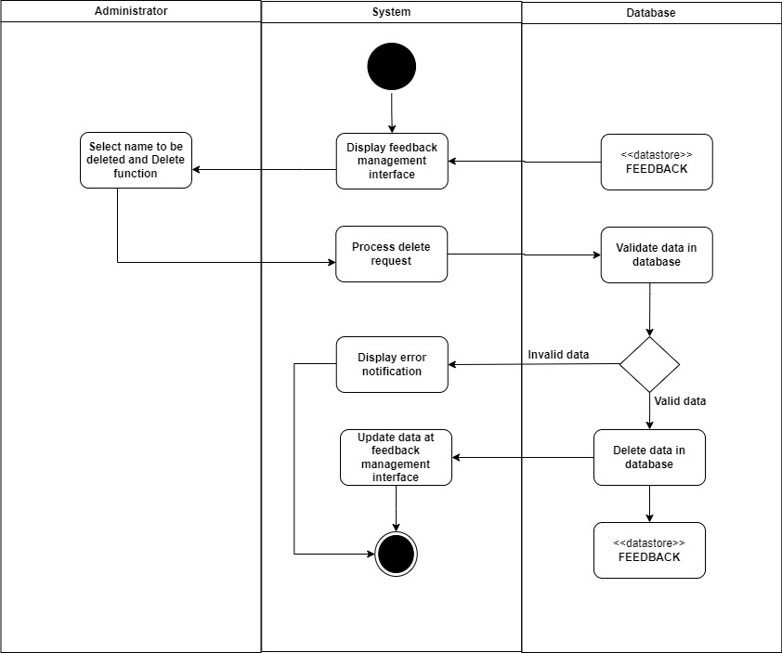

#### Search feedback

|  |  |
| --- | --- |
| Use case name | Search feedback. |
| Description | Administrator searches a feedback information. |
| Trigger | Administrator clicks to button “Manage Feedback” sidebar. |
| Pre-condition | Administrator’s device must connect to the Internet.  Administrator’s must log in to the system. |
| Post-condition | Administrator gets detailed information about a feedback. |
| Basic flow | 1. The system displays feedback management interface with data loaded from the database.  2. Administrator enters feedback’s ID on the text field.  3. The system processes search request.  4. The system queries feedback related to ID.  5. The system displays result at the feedback management interface. |
| Alternative flow | 4a. The system displays empty results when the system can’t find a correct feedback.  Use-case stop. |
| Exception flow |  |
| Use case name | Search feedback. |
| Description | Administrator searches a feedback information. |
| Trigger | Administrator clicks to button “Manage Feedback” sidebar. |
| Pre-condition | Administrator’s device must connect to the Internet.  Administrator’s must log in to the system. |
| Post-condition | Administrator gets detailed information about a feedback. |
| Basic flow | 1. The system displays feedback management interface with data loaded from the database.  2. Administrator enters feedback’s ID on the text field.  3. The system processes search request.  4. The system queries feedback related to ID.  5. The system displays result at the feedback management interface. |
| Alternative flow | 4a. The system displays empty results when the system can’t find a correct feedback.  Use-case stop. |
| Exception flow |  |

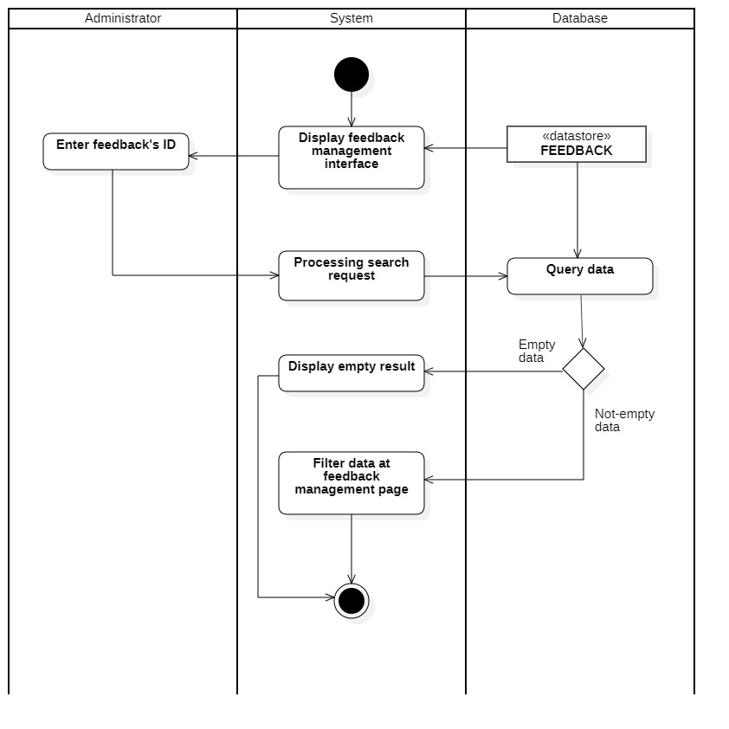

* + 1. **Apartment booking statistics**

|  |  |
| --- | --- |
| Use case name | Apartment booking statistics (for Administrator). |
| Description | Administrator can statistic the number of guests who have booked the apartment. |
| Trigger | Administrators clicks to button “Analysis” at management page |
| Pre-condition | Administrator’s device must connect to the Internet.  Administrator’s must log in to the system. |
| Post-condition |  |
| Basic flow | 1. Administrator select analysis.  2. System get list of invoices from database  3. Group data by selected category  4. Create interactive visual chart  5. Display charts |
| Alternative flow |  |
| Exception flow |  |

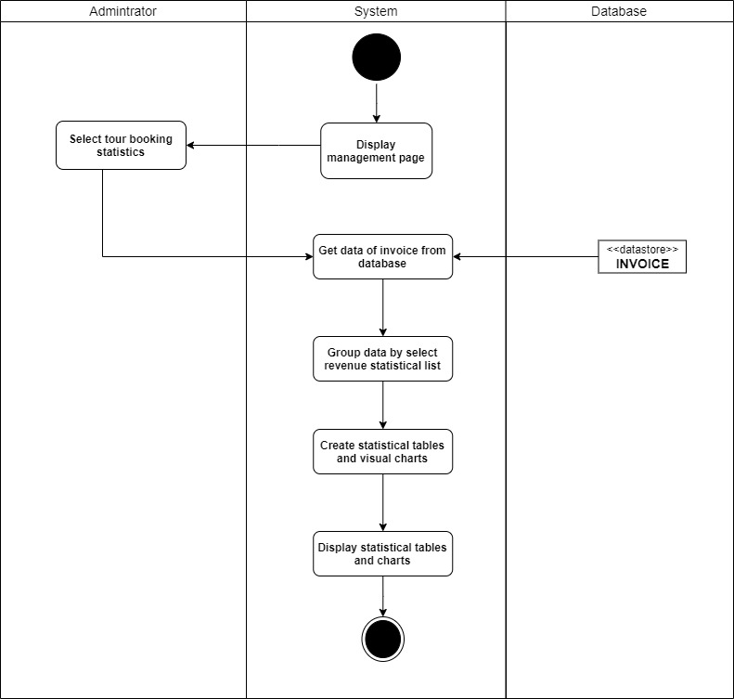

## **Sequence Diagram and Class Diagram**



### **Sign up**

#### Sequence diagram

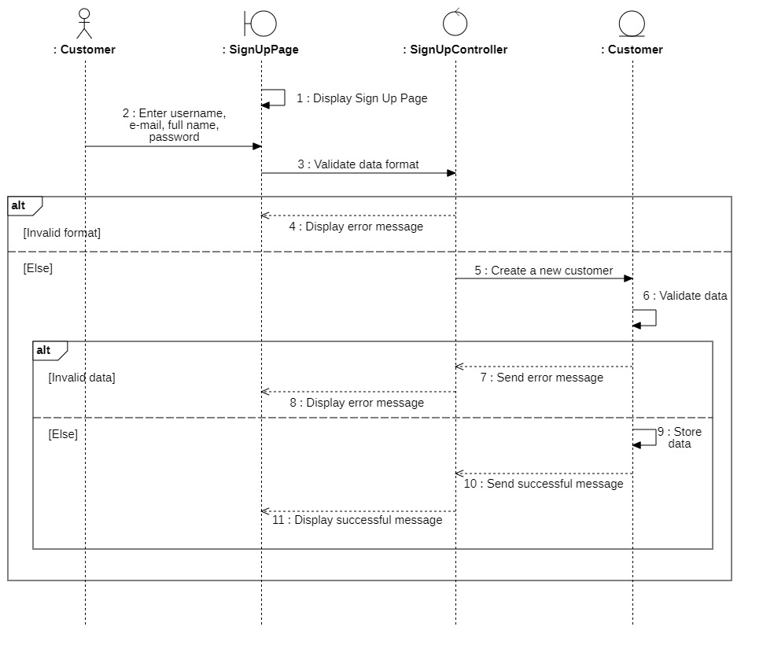

#### Class diagram

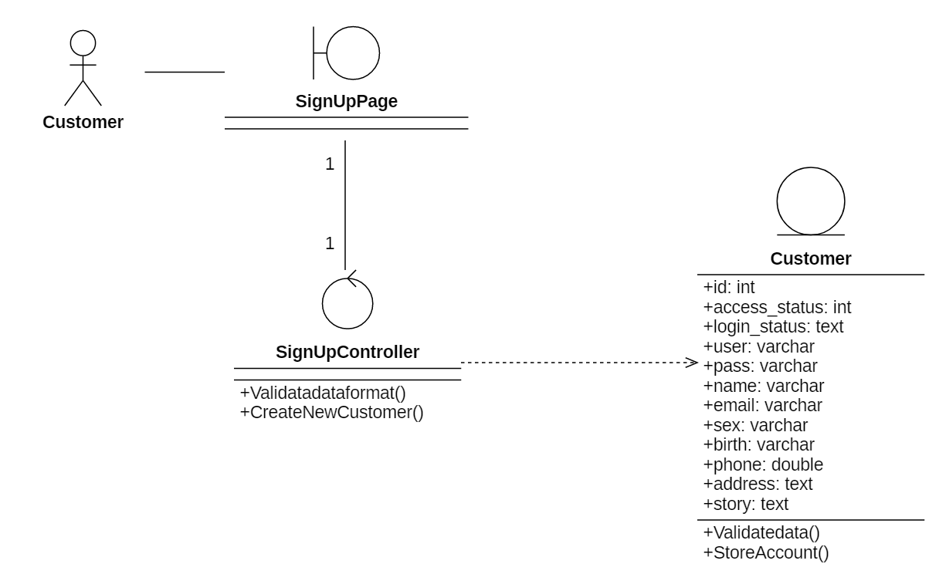

### **Sign in (for customer)**

#### Sequence diagram

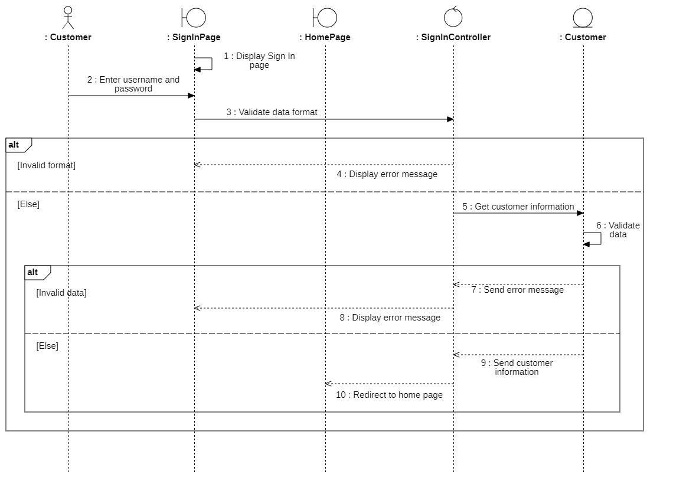

#### Class diagram

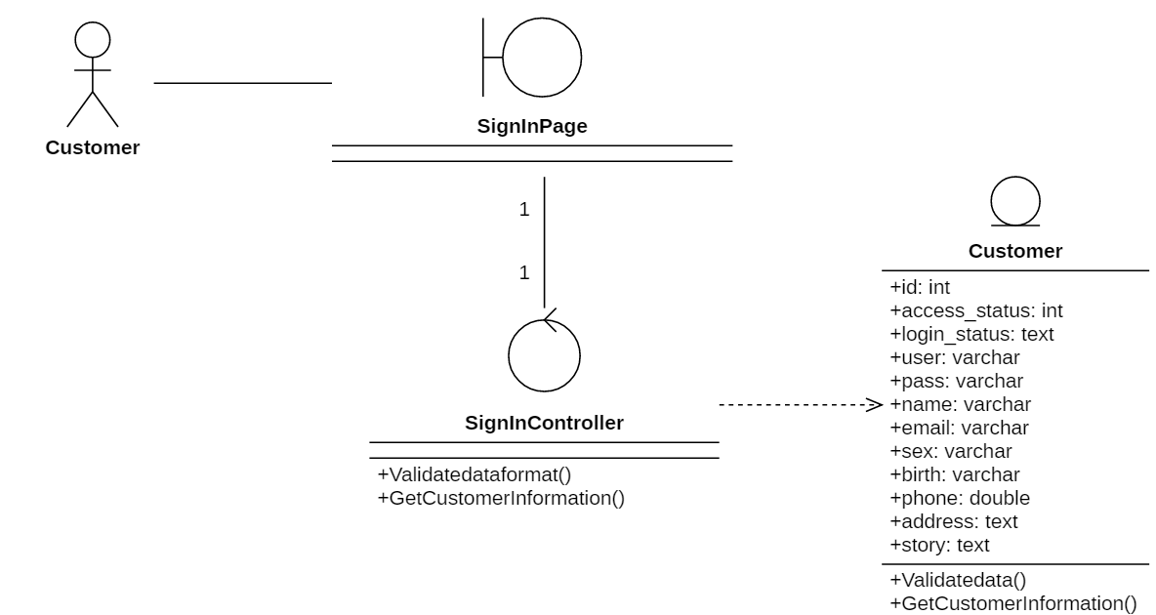

### **Search apartment (for customer)**

#### Sequence diagram

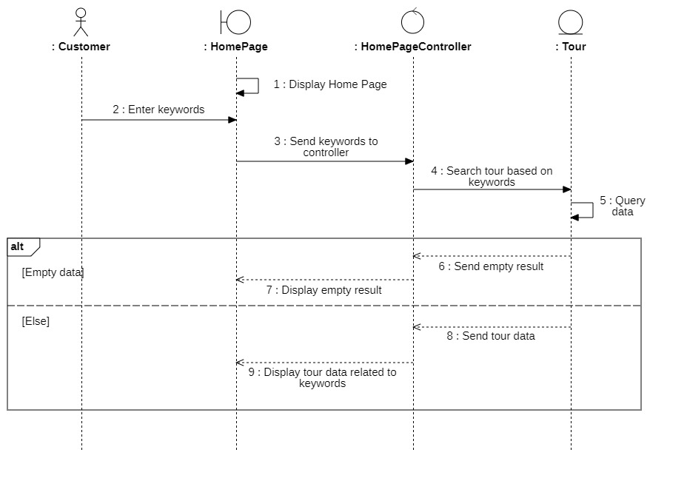

#### Class diagram

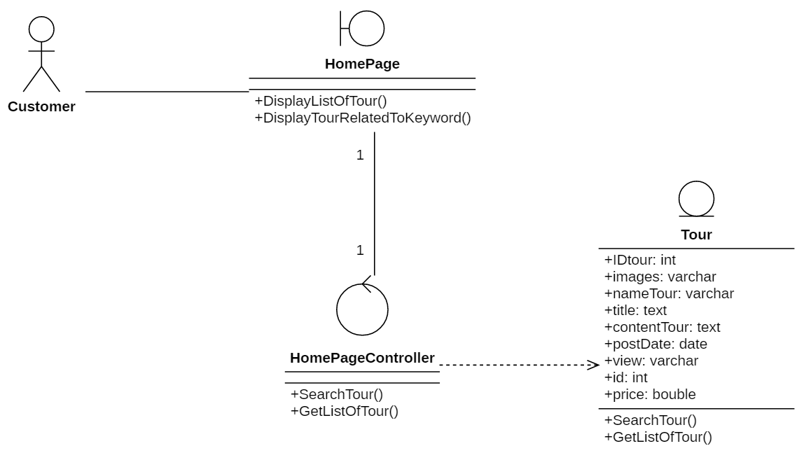

### **Book apartment (for customer)**

#### Sequence diagram

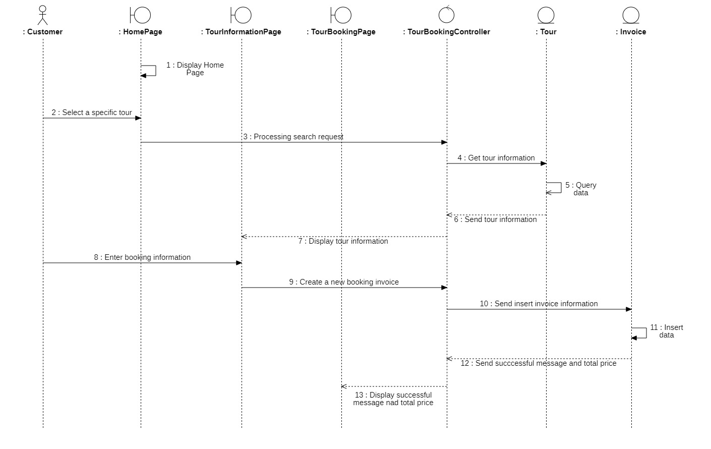

#### Class diagram

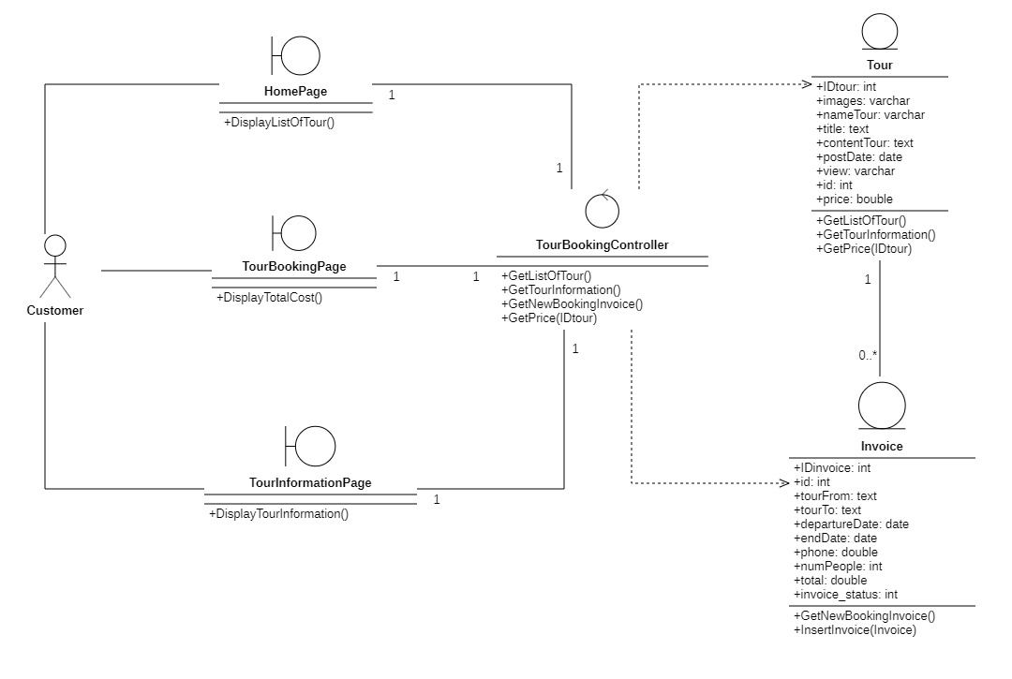

### **Sign in (for administrator)**

#### Sequence diagram

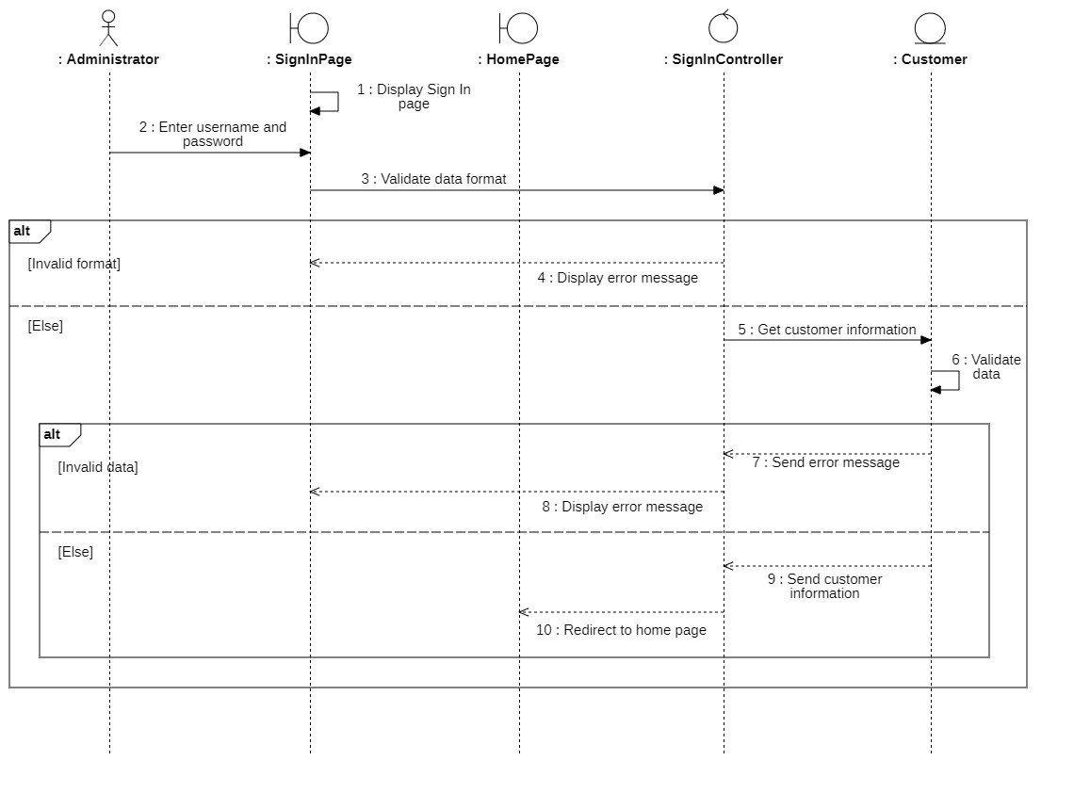

#### Class diagram

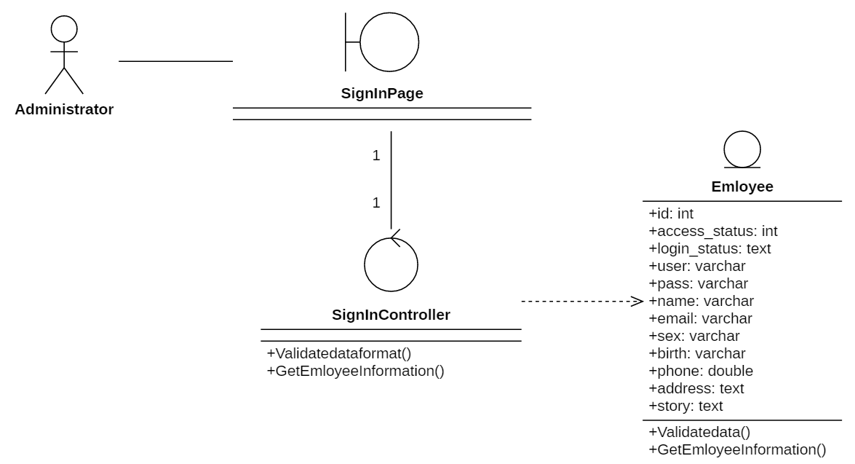

### **Change password (for administrator)**

#### Sequence diagram

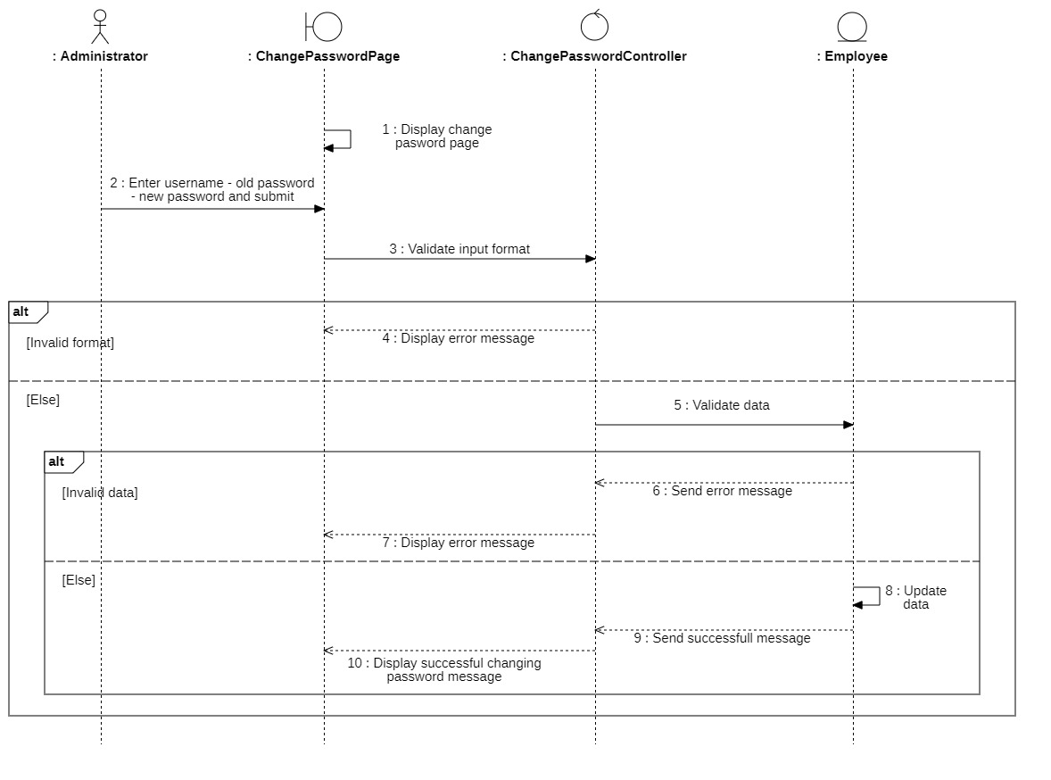

#### Class diagram

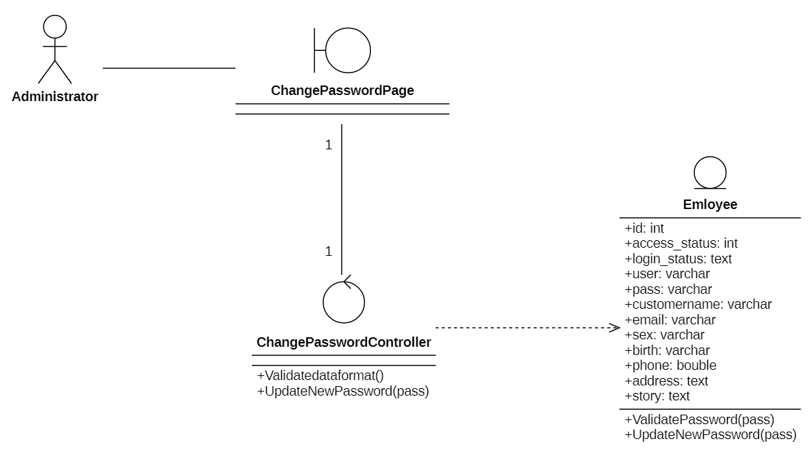

### **Search apartment (for administrator)**

#### Sequence diagram

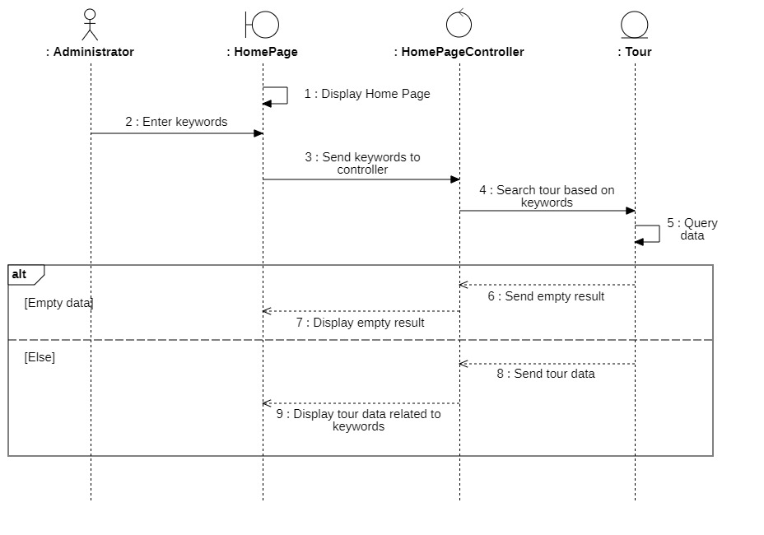

#### Class diagram

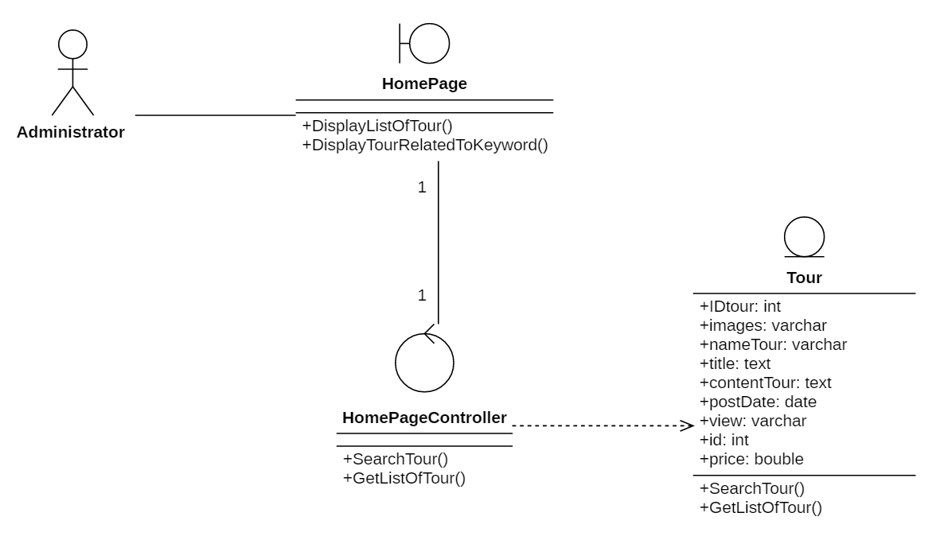

### **Book apartment (for administrator)**

#### Sequence diagram

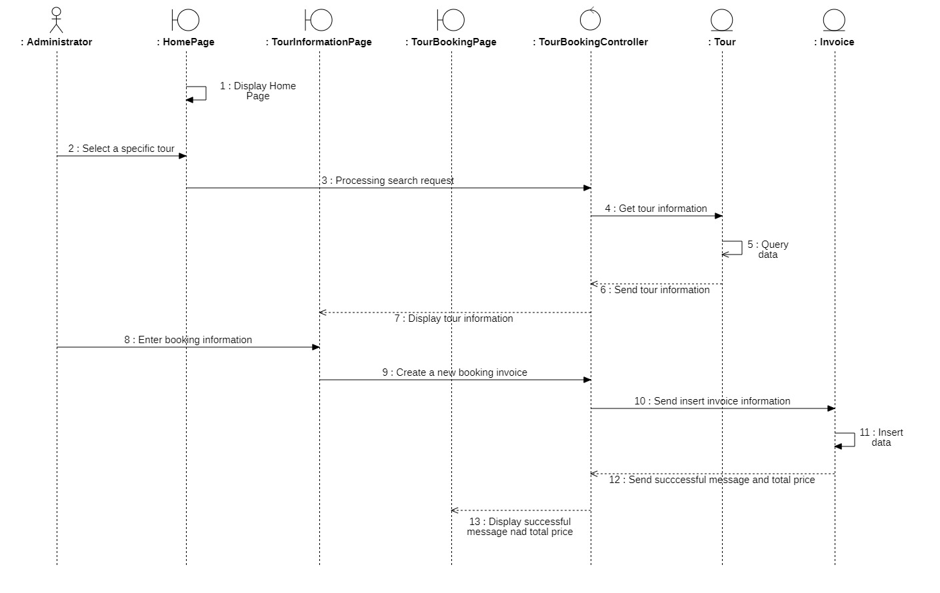

#### Class diagram

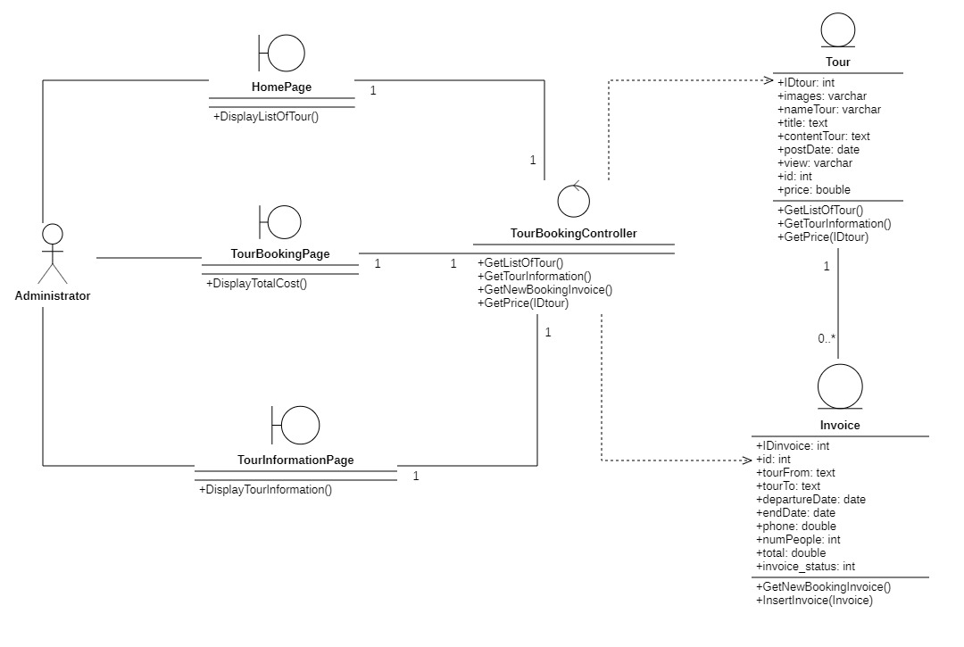

### **Give feedback (for administrator)**

#### Sequence diagram

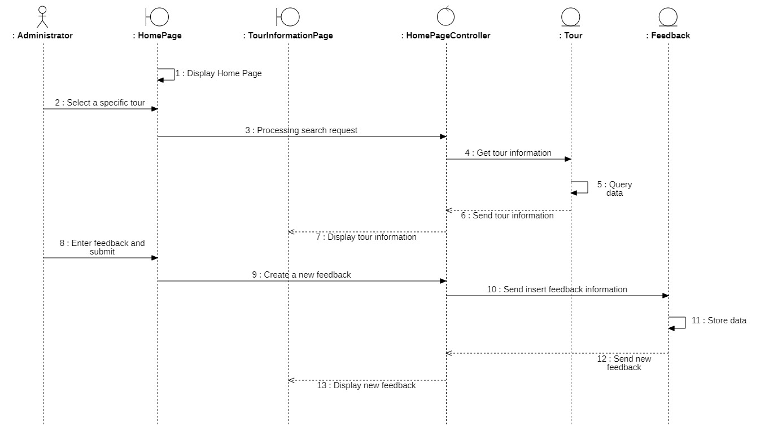

#### Class diagram

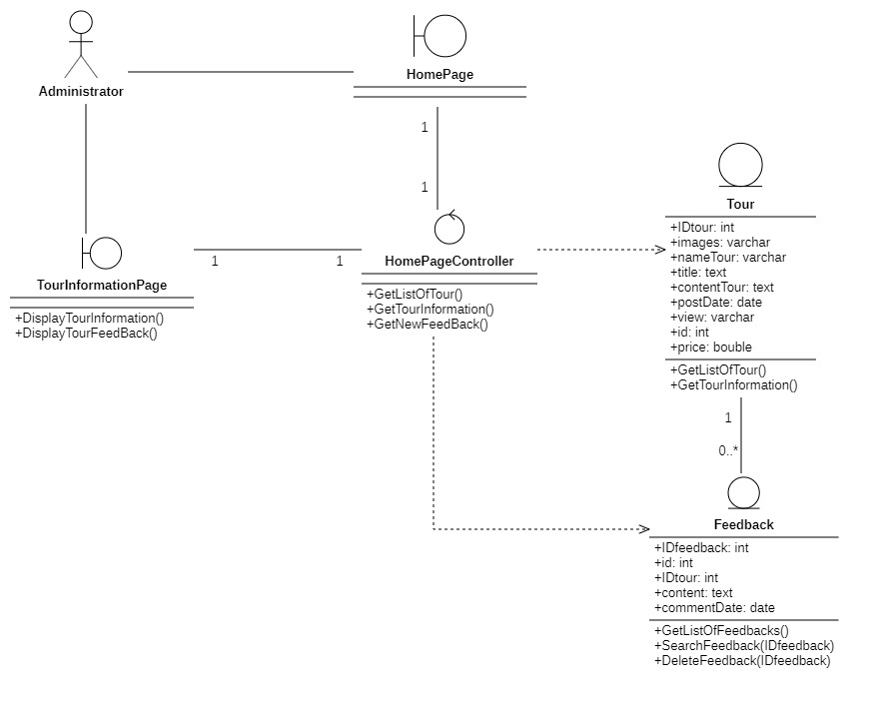

### **Manage apartments**

#### Sequence diagram

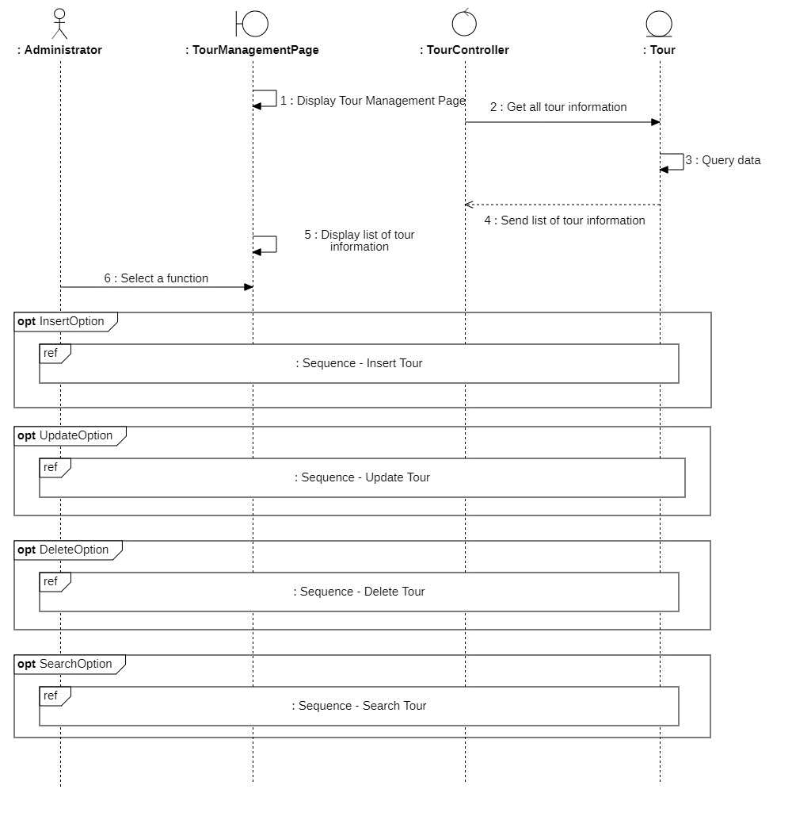

##### Insert apartment

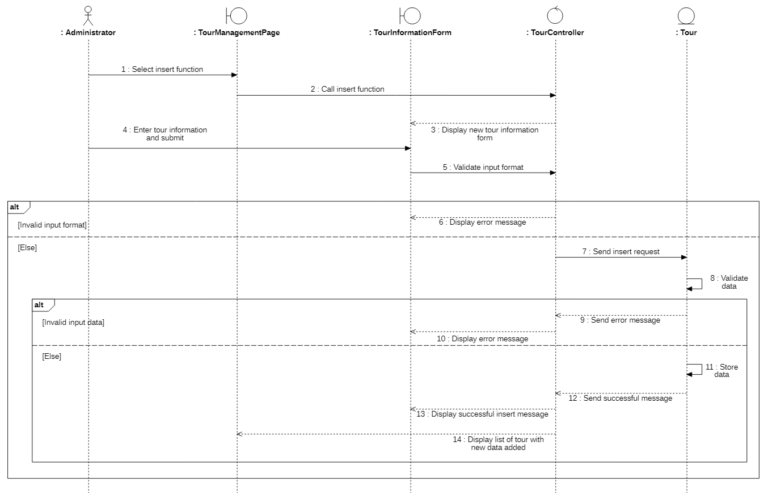

##### Update apartment

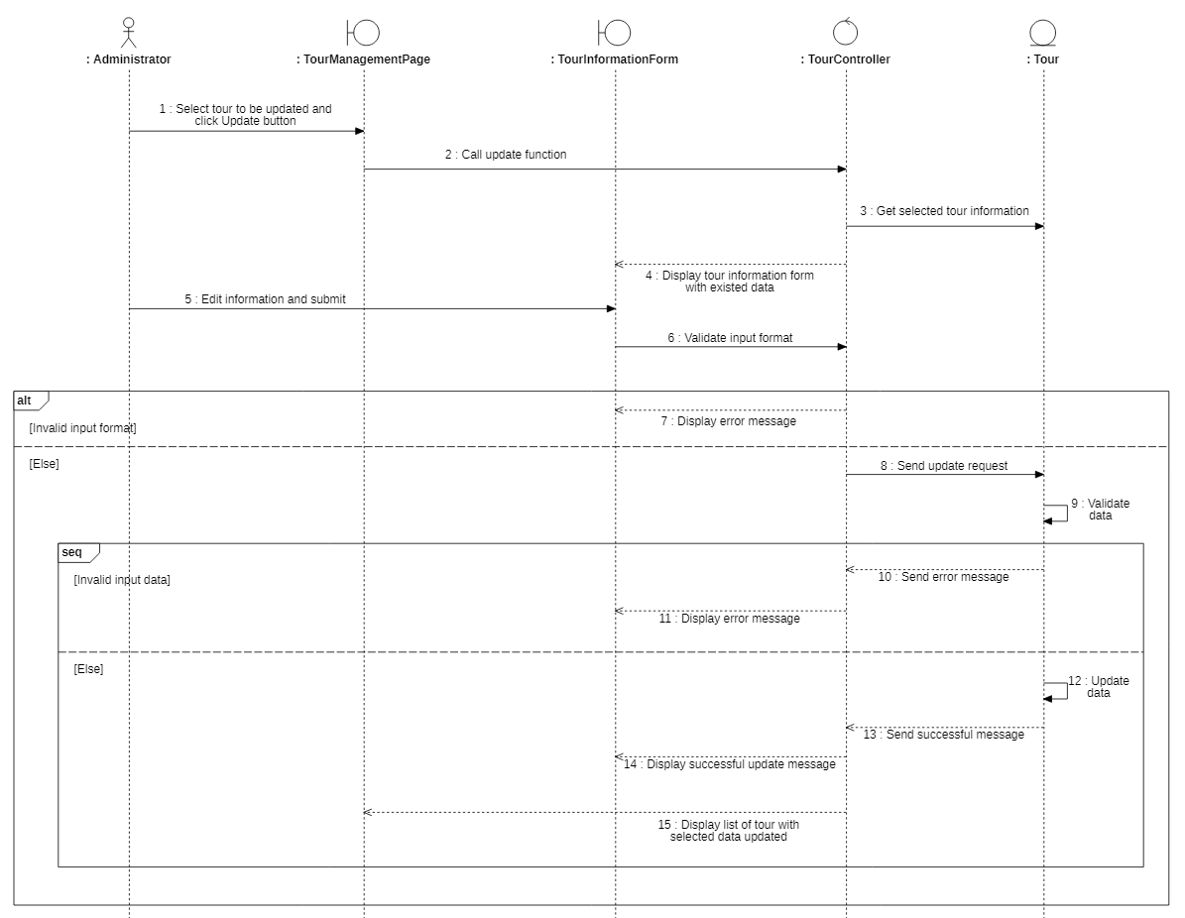

##### Delete apartment

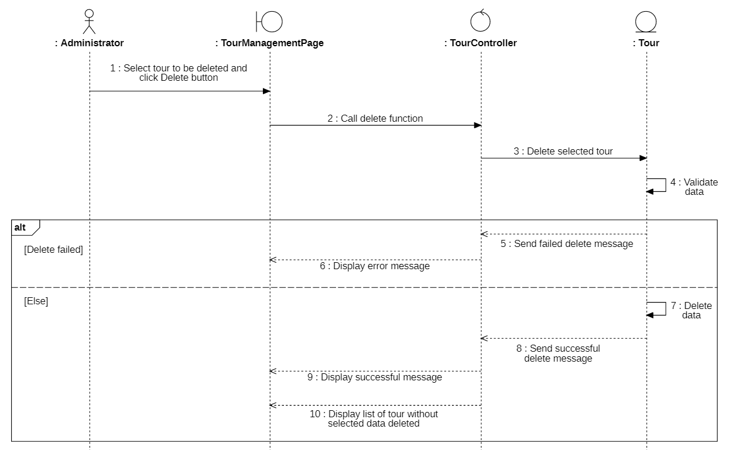

##### Search apartment

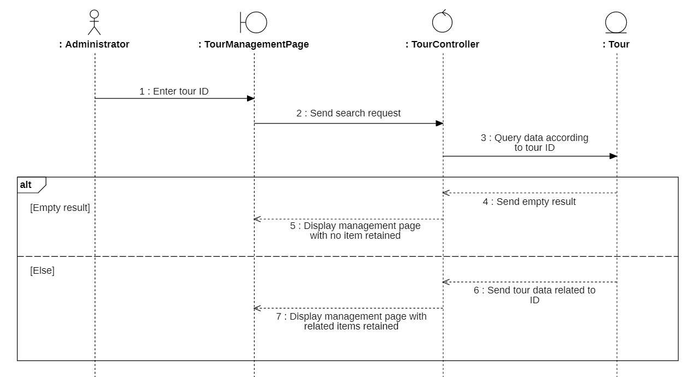

#### Class diagram

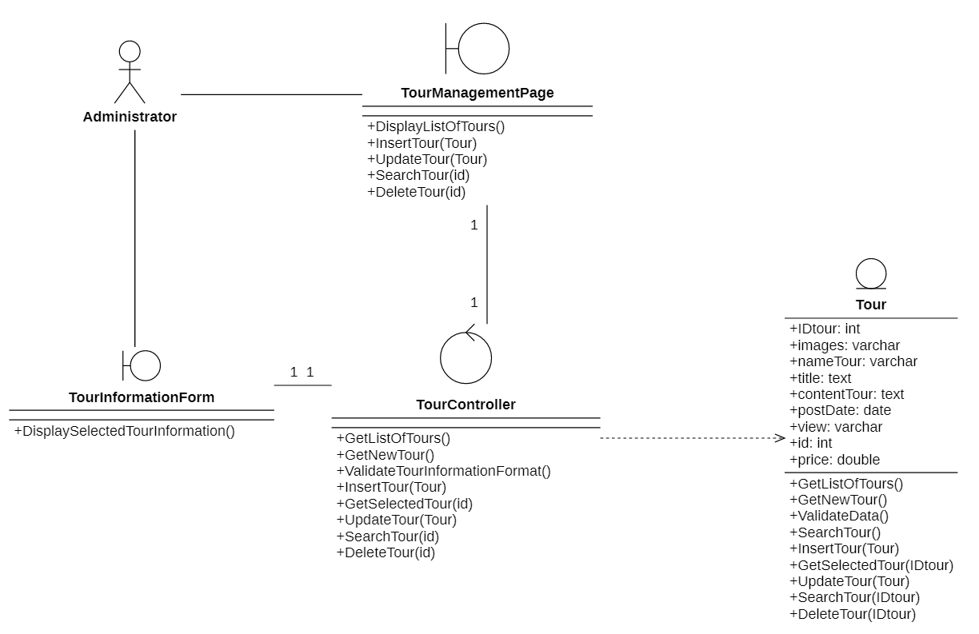

### **Manage invoices**

#### Sequence diagram

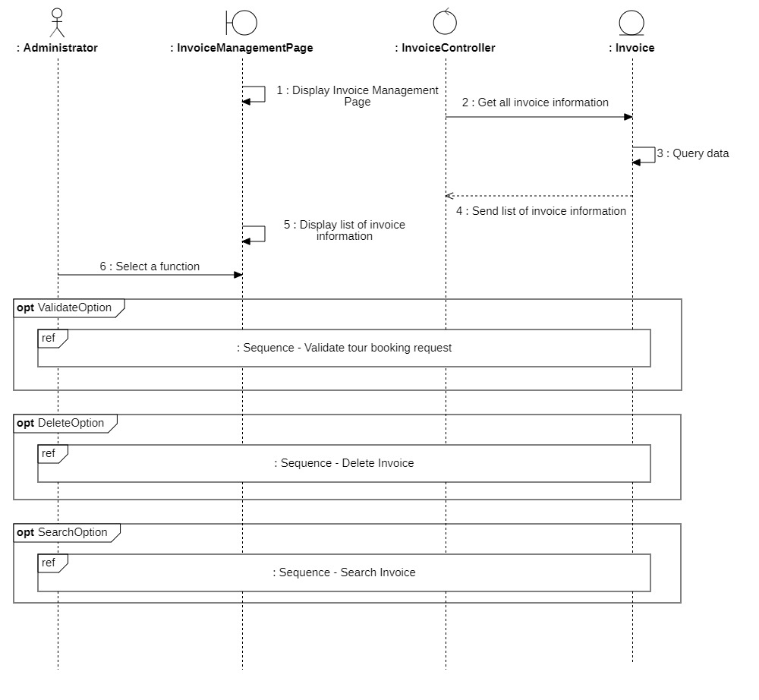

##### Delete invoice

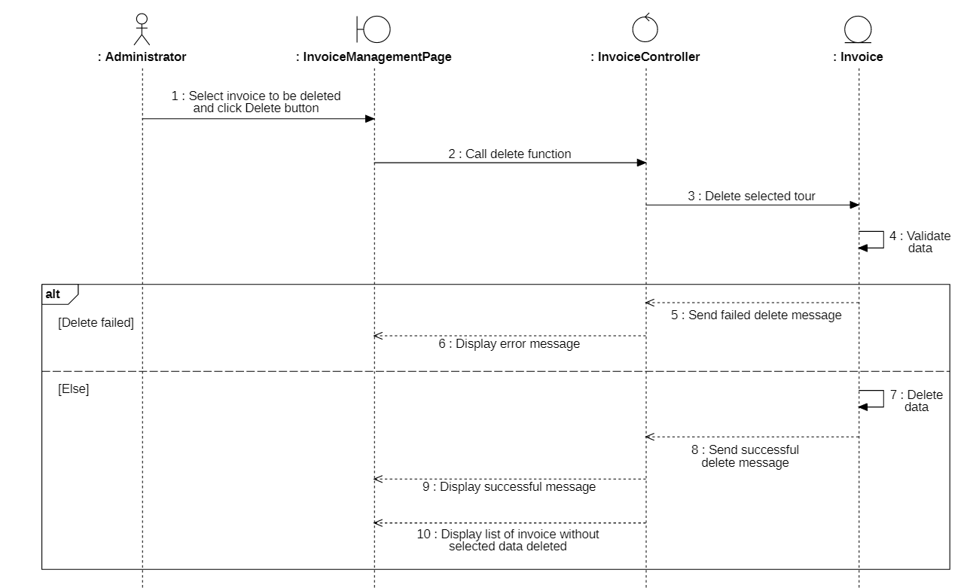

##### Search invoice

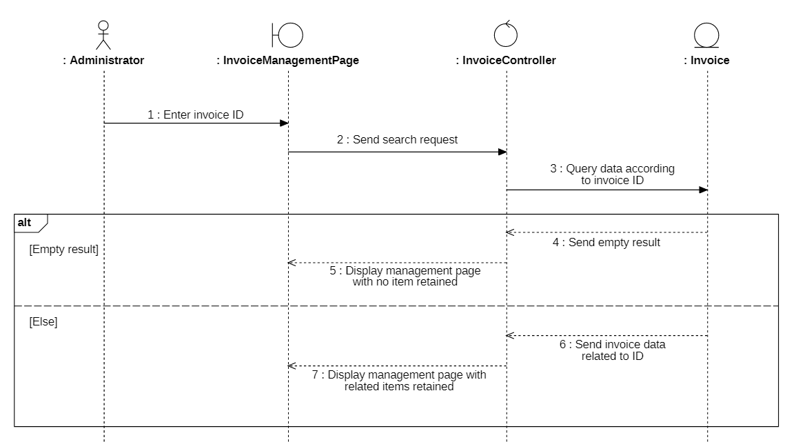

##### Validate apartment booking request

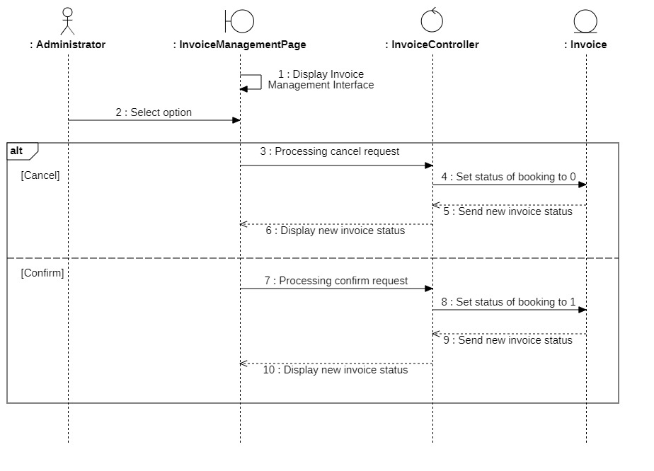

#### Class diagram

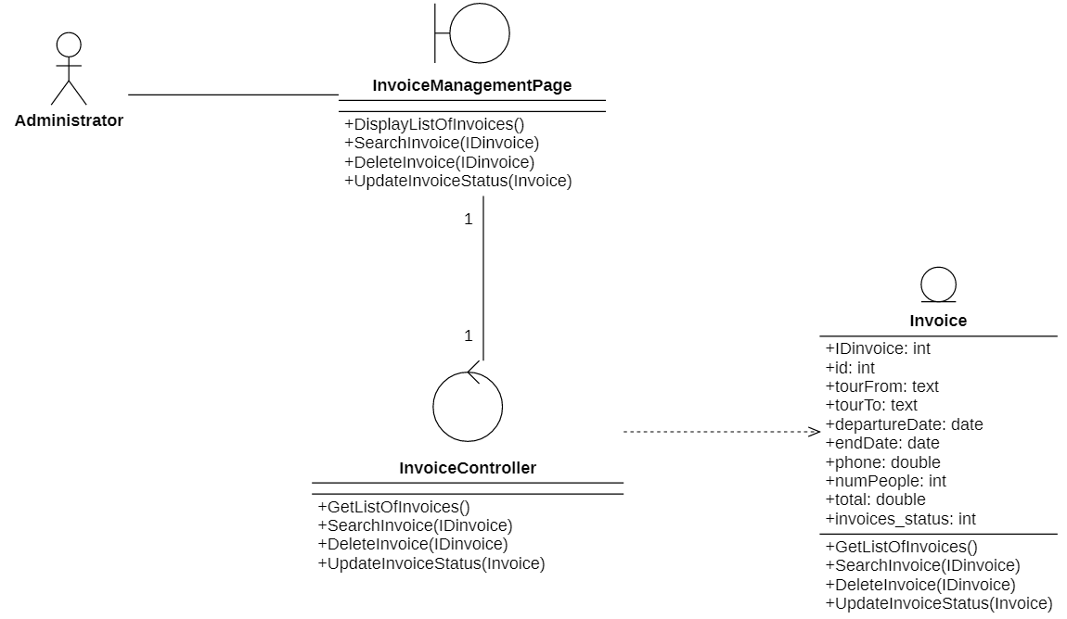

### **Manage feedback**

#### Sequence diagram

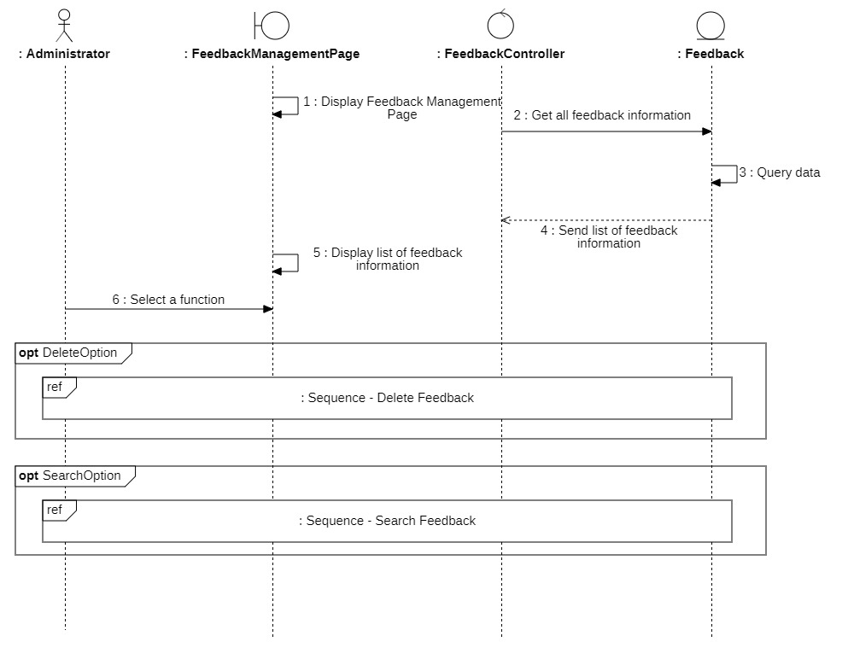

##### Delete feedback

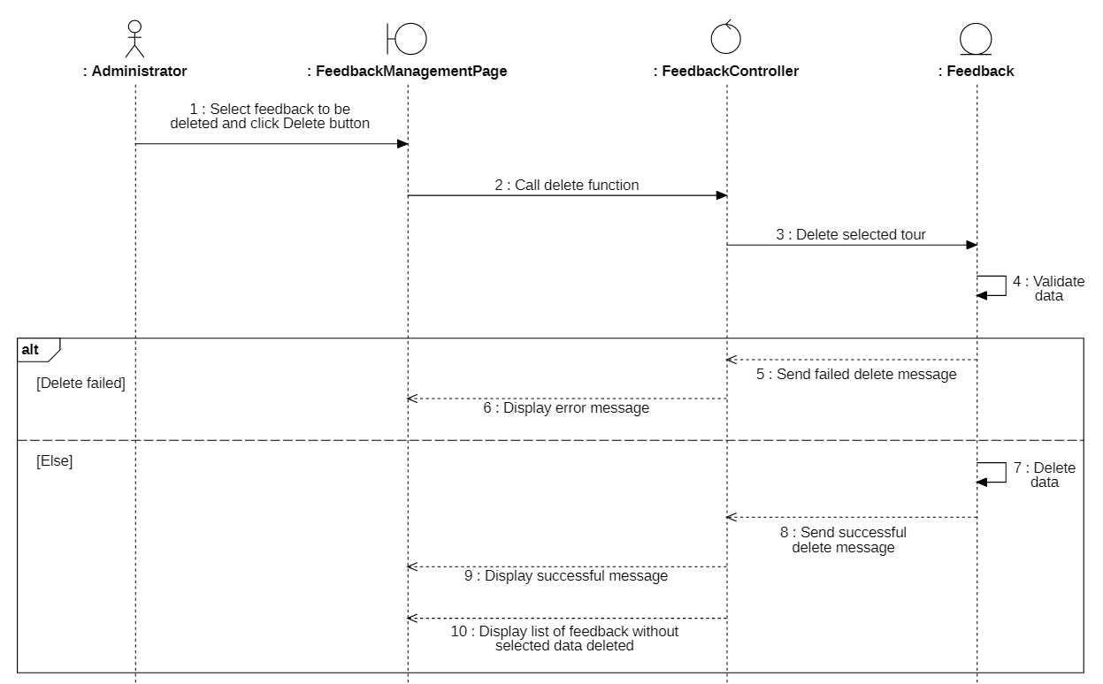

##### Search feedback

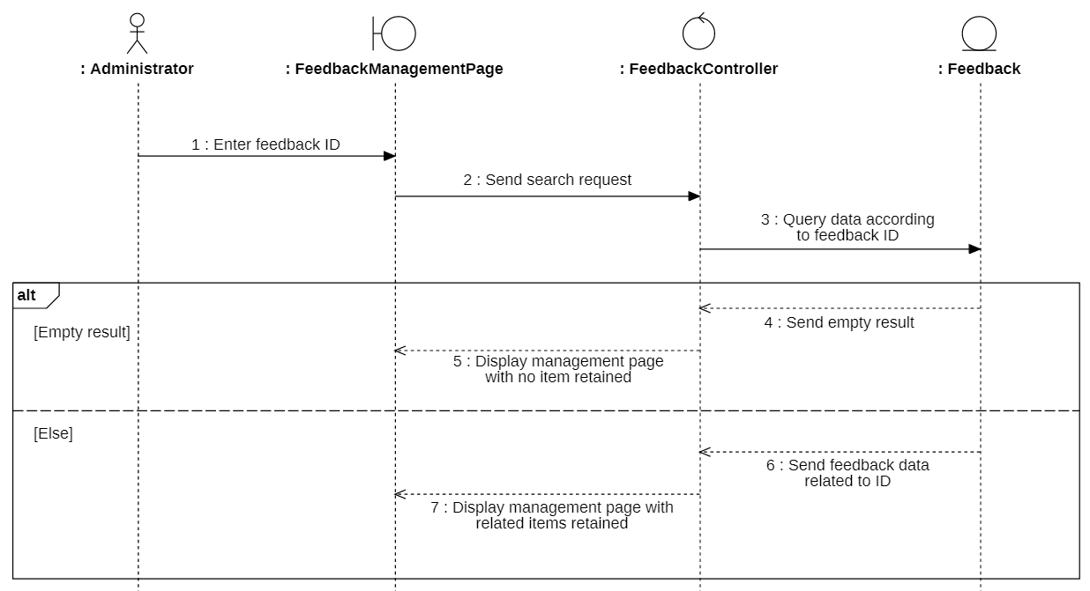

#### Class diagram

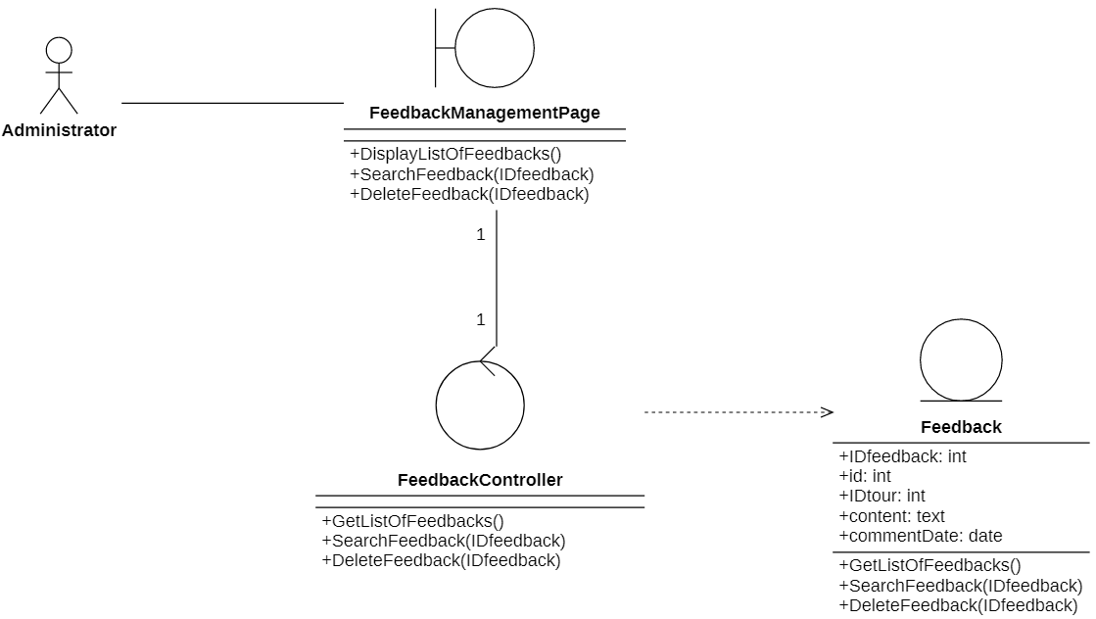

* + 1. **Apartment booking statistics**

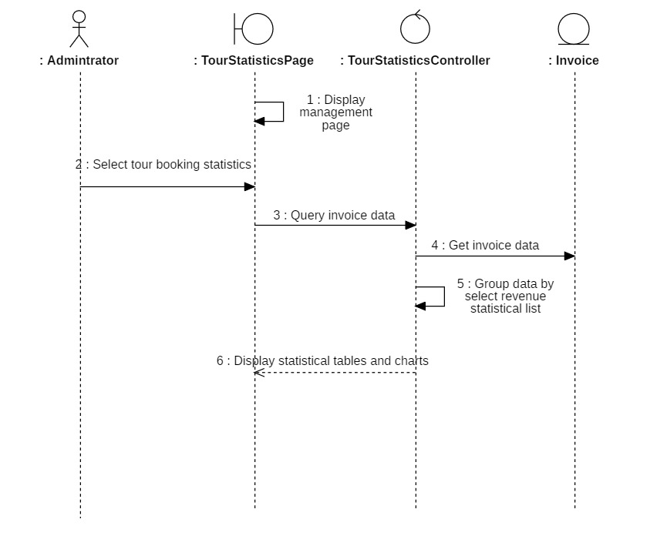

## **Class Diagram and Entity class diagram**



### **Customer overview class diagram**

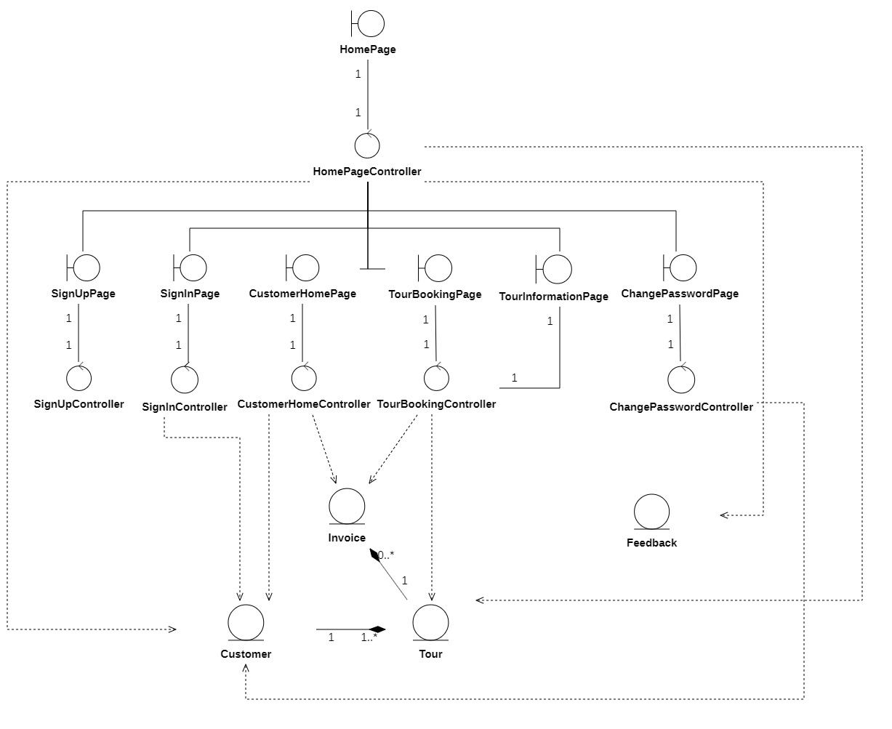

### **Administrator overview class diagram**

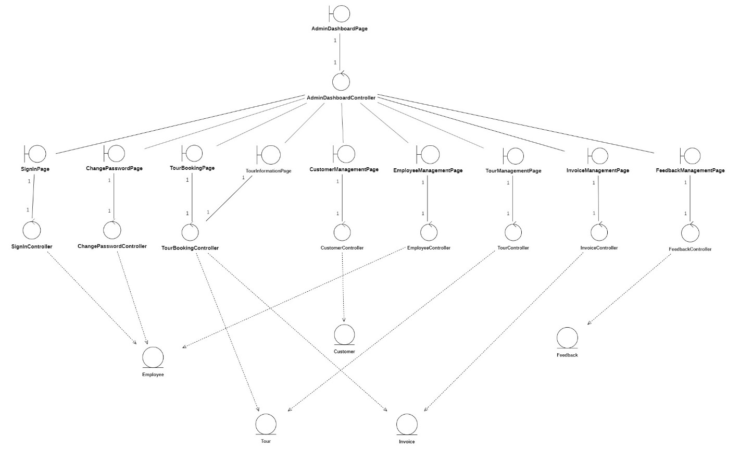

### **Entity class diagram**

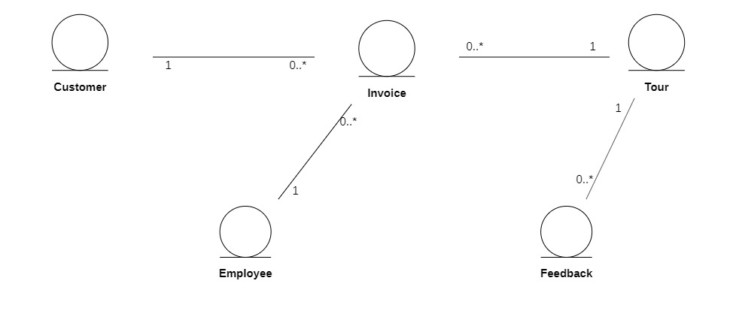

### **Class diagram specification**

* + - 1. **Customer**

|  |  |  |
| --- | --- | --- |
| **Customer** | | |
|  | **Variable** | **Meaning** |
| **Attribute** | Id: int | Customer ID generated by system. |
| Access_status: int | This status is used to distinguish which user is customer, which user is employee. |
| Login_status: text | This status is used when customer signs in. 1 is has-sign-in status. 0 is the reverse. |
| User: varchar | Username account of user. |
| Pass: varchar | Password of user. |
| Customer_name: varchar | Name of user. |
| Email: varchar | Email of customer. |
| Sex: varchar | Gender of customer. |
| Birth: date | Customer's date of birth. |
| Phone: double | Customer phone number. |
| Address: text | Customer's address. |
| Story: text | About the customer's personality and preferences. |
|  | **Function** | **Meaning** |
| **Operation** | GetListOfCustomer() | Request to get list of customer has in database. |
| GetNewCustomer() | Request to get a new customer. |
| ValidateCustomerInformation() | Validate customer information to know the entering information. |
| InsertCustomer() | Request to create new customer and validate function precondition. |
| GetSelectedCustomer(id) | Request to get selected customer information with id. |
| UpdateCustomer(Customer) | Request to update the existing customer information and confirm the precondition of the function |
| SearchCustomer(id): | Request to search customer information with keyword-related to id. |
| DeleteCustomer(id): | Request to delete the existing customer information. |
| GetCustomerInformation(): | Request to get customer information. |
| ValidateData(): | Validate data information is entered in correct format. |
| StoreAccount(): | Save information in database. |
| ValidatePassword(pass): | Validate password with the existing data in the databse. |
| UpdateNewPassword(pass): | Update new password is correctly formatted to the database |
| UpdateProfile(Customer): | Request to update the existing customer information and confirm the precondition of the function. |

* + - 1. **Employee**

|  |  |  |
| --- | --- | --- |
| **Employee** | | |
|  | **Variable** | **Meaning** |
| **Attribute** | Id: int | Employee ID generated by system |
| Access_status: int | This status is used to distinguish which user is customer, which user is employee. |
| Login_status: text | This status is used when employee signs in. 1 is has-sign-in status. 0 is the reverse |
| User: varchar | Name of user |
| Pass: varchar | Password of user |
| Customer_name: varchar | Name of user |
| Email: varchar | Email of employee |
| Sex: varchar | Gender of employee |
| Birth: date | Employee's date of birth |
| Phone: double | Employee’s phone number |
| Address: text | Employee's address |
| Story: text | About the employee's personality and preferences |
|  | **Function** | **Meaning** |
| **Operation** | GetListOfEmployee() | Request to get list of employee has in database. |
| GetNewEmployee() | Request to get a new customer |
| ValidateEmployeeInformation() | Validate employee information to know the entering information |
| InsertEmployee(Employee) | Request to create new customer and validate function precondition. |
| GetSelectedEmployee(id) | Request to get selected employee information with id. |
| UpdateEployee(Employee) | Request to update the existing employee information and confirm the precondition of the function |
| SearchEmployee(id) | Request to search employee information with keyword-related to id. |
| DeleteEmployee(id) | Request to delete the existing Employee information. |
| ValidateData() | Validate data information is entered in correct format |
| GetEmployeeInformation() | Request to get existing customer information in profile |
| ValidatePassword(pass) | Validate password with the existing data in the database |
| UpdateNewPassword(pass) | Update new password is correctly formatted to the database |
| UpdateProfile(Employee) | Request to update the existing employee information and confirm the precondition of the function. |

* + - 1. **Apartment**

|  |  |  |
| --- | --- | --- |
| **Apartment** | | |
|  | **Variable** | **Meaning** |
| **Attribute** | IDapartment: int | Apartment ID generated by system |
| Images: varchar | Images of apartmentist attractions |
| nameApartment: varchar | Name of the apartmentist destination |
| Title: text | Title of apartmentist destination |
| contentApartment: text | Content of apartmentist destination |
| postDate: date | Post date |
| view: varchar | View |
| Id: int | Employee ID generated by system |
| Price: double | Price of the trip/people |
|  | **Function** | **Meaning** |
| **Operation** | GetListOfApartments(): | Request to get list of apartment has in database. |
| GetNewApartment(): | Request to get a new apartment |
| ValidateData(): | Validate data information is entered in correct format |
| InsertApartment(apartment): | Request to create new apartment and validate function precondition |
| GetSelectedApartment(IDapartment): | Request to get selected apartment information with id |
| UpdateApartment(apartment): | Request to update the existing apartment information and confirm the precondition of the function |
| SearchApartment(IDapartment): | Request to search apartment information with keyword-related to id. |
| DeleteApartment(IDapartment) | Request to delete the existing apartment information. |
| GetApartmentInformation(): | Request to get existing apartment information in profile |
| GetPrice(IDapartment): | Request to get price of apartment has in database |

* + - 1. **Invoice**

|  |  |  |
| --- | --- | --- |
| **Invoice** | | |
|  | **Variable** | **Meaning** |
| **Attribute** | IDinvoice: int | Apartment ID generated by system |
| id: int | Customer ID generated by system |
| apartmentFrom: text | Starting location |
| apartmentTo: text | Destination |
| departureDate: date | Departure date |
| endDate: date | End date |
| Phone: double | Customer’s phone number |
| numPeople: int | Number of people |
| Total: double | Total invoice |
| Invoice_status: int | Invoice status |
|  | **Function** | **Meaning** |
| **Operation** | GetListOfInvoices(): | Request to get list of invoice has in database. |
| SearchInvoice(IDinovoice): | Request to search invoice information with keyword-related to id. |
| DeleteInvoice(IDinvoice): | Request to delete the existing apartment information. |
| UpdateInovoiceStatus(IDinvoice): | Request to update invoice status after being confirmed by administrator |
| GetNewBookingInvoice(): | Request to get a new invoice just booked |
| InsertInvoice(Invoice): | Request to create new invoice and validate function precondition |
| GetCustomerInvoice(): | Request to get the invoice of the booked customer |

* + - 1. **Feedback**

|  |  |  |
| --- | --- | --- |
| **Feedback** | | |
|  | **Variable** | **Meaning** |
| **Attribute** | IDfeedback: int | Apartment ID generated by system |
| id: int | Customer ID generated by system |
| IDapartment: int | Starting location |
| Content: text | Destination |
| commentDate: date | Departure date |
|  | **Function** | **Meaning** |
| **Operation** | GetListOfFeedback() | Request to get list of feedback has in database. |
| SearchFeedback(IDfeedback) | Request to search feedback information with keyword-related to id. |
| DeleteFeedback(Idfeedback) | Request to delete the existing apartment information |
| GetNewFeedBack() | Request to get new feedback |
| InsertNewFeedback() | Request to create new feedback and validate function precondition. |

* + - 1. **Apartment Controller**

|  |  |  |
| --- | --- | --- |
| **Apartment Controller** | | |
|  | **Function** | **Meaning** |
| **Operation** | GetListOfApartment() | Request database to get list of apartment to display on the apartment management page |
| GetNewApartment() | Request databases get a new apartment just booked on the apartment management page |
| ValidateData() | Validate data format of information is entered in correct format |
| InsertApartment(Apartment) | Request databases create new feedback and validate function precondition |
| GetSelectedApartment(IDapartment) | Request database to get information of the selected Apartment |
| UpdateApartment(Apartment) | Request database to update the existing apartment information and confirm the precondition of the function |
| SearchApartment(IDapartment) | Request database to get a list of  Apartment system related to key word |
| DeleteApartment(IDapartment) | Request database to delete the existing apartment information |

* + - 1. **Customer Controller**

|  |  |  |
| --- | --- | --- |
| **Customer Controller** | | |
|  | **Function** | **Meaning** |
| **Operation** | GetListOfCustomer() | Request database to get list of customer has in customer system on the customer management page |
| GetNewCustomer() | Request databases get a new customer just insert on the customer management page |
| ValidateCustomerData() | Validate customer information is not the same as entered information |
| InsertCustomer(Customer) | Request database to create new customer and validate function precondition |
| GetSelectedCustomer(id) | Request database to return selected customer information with id on customer management page |
| UpdateCustomer(Customer) | Request database to update the existing customer information and confirm the precondition of the function |
| SearchCustomer(id) | Request database to return customer information with keyword-related id |
| DeleteCustomer(id) | Request database to delete the existing customer information |

* + - 1. **Employee Controller**

|  |  |  |
| --- | --- | --- |
| **Employee Controller** | | |
|  | **Function** | **Meaning** |
| **Operation** | GetListOfEmployee() | Request database to get list of Employee system on the employee management page |
| GetNewEmployee() | Request databases get a new customer just insert on the Employee management page |
| ValidateEmployeeInformation() | Validate Employee information is not the same as entered information |
| InsertEmployee(Employee) | Request database to create new Employee and validate function precondition |
| GetSelectedEmployee(id) | Request database to return selected employee information with id on Employee management page |
| UpdateEmployee(Employee) | Request database to update the existing Employee information and confirm the precondition of the function |
| SearchEmployee(id) | Request database to return Employee information with keyword-related id |
| DeleteEmployee(id) | Request database to delete the existing Employee information |

* + - 1. **Feedback Controller**

|  |  |  |
| --- | --- | --- |
| **Feedback Controller** | | |
|  | **Function** | **Meaning** |
| **Operation** | GetListOfFeedback() | Request database to get list of feedback has in database on the feedback management page |
| SearchFeedback(IDfeedback) | Request database to return feedback information with keyword-related id |
| DeleteFeedback(IDfeedback) | Request database to delete the existing feedback information |

* + - 1. **Invoice Controller**

|  |  |  |
| --- | --- | --- |
| **Invoice Controller** | | |
|  | **Function** | **Meaning** |
| **Operation** | GetListOfInvoice() | Request database to get list of Invoice system |
| UpdateInvoice(IDinvoice) | Request database to update the existing Invoice information and confirm the precondition of the function |
| SearchInvoice(IDinvoice) | Request database to return Invoice information with keyword-related id |
| DeleteInvoice(invoice) | Request database to delete the existing Invoice information |
|  | GetCustomerInvoice() | Get the invoice of the booked customer |
|  | UpdateInvoiceStatus(Idinvoice) | Update invoice status after being confirmed by administrator |

* + - 1. **Customer Sign In Controller**

|  |  |  |
| --- | --- | --- |
| **Customer Sign In Controller** | | |
|  | **Function** | **Meaning** |
| **Operation** | GetCustomerInformation() | Request database to get customer information related id on the customer management page |
| ValidateData () | Validate data format of information is entered in correct format |

* + - 1. **Administrator Sign In Controller**

|  |  |  |
| --- | --- | --- |
| **Customer Sign In Controller** | | |
|  | **Function** | **Meaning** |
| **Operation** | GetEmployeeInformation() | Get Employee information related id |
| ValidateData() | Validate data format of information is entered in correct format |

* + - 1. **Customer Sign Up Controller**

|  |  |  |
| --- | --- | --- |
| **Customer Sign In Controller** | | |
|  | **Function** | **Meaning** |
| **Operation** | ValidataData() | Validate data format of information is entered in correct format |
| CreateNewCustomer() | Request the database to create a new  customer on it. Validation function is prerequisite for this function |

* + - 1. **Customer Change Password Controller**

|  |  |  |
| --- | --- | --- |
| **Customer Change Password Controller** | | |
|  | **Function** | **Meaning** |
| **Operation** | ValidateData() | Validate data format of information is entered in correct format |
| UpdateNewPassword(pass) | Request database to update new password is correctly formatted on the customer management page |

* + - 1. **Home Page Controller**

|  |  |  |
| --- | --- | --- |
| **Home Page Controller** | | |
|  | **Function** | **Meaning** |
| **Operation** | SearchApartment() | Request database to get a list of  Apartment system related to key word |
| GetListOfApartment() | Request database to get list of apartment to display on the home page |
| GetApartmentInformation() | Request database to get Apartment information related id on the home page |
| GetNewBookingInvoice() | Request database to get a new invoice just booked on the home page |
| GetPrice(IDapartment) | Request database to get price of apartment has in database on the home page |
| GetNewFeedback() | Request database to get the feedback of the in feedback database on the home page |



## **State Diagram**

### **Invoice**

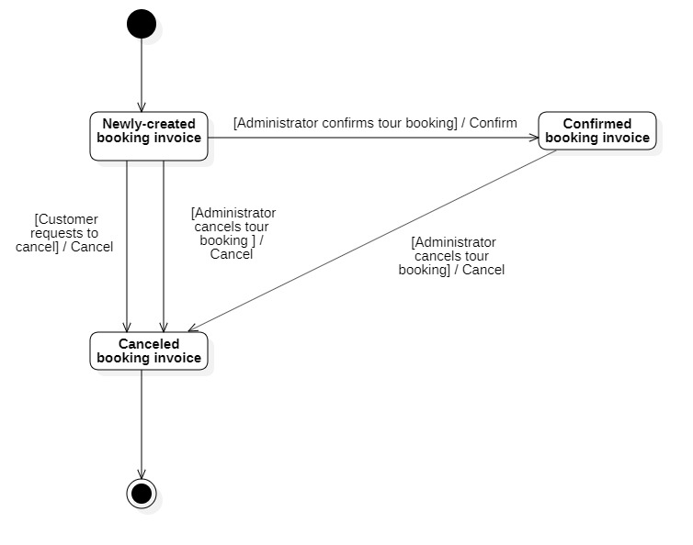

**Mapping to Relational Model from Entity class diagram**

# **Chapter 4: IMPLEMENTATION AND TESTING**



## **Introduction to the implementation environment**



### **Development environment**

* Operating system: Windows 10
* Database: MySQL
* Text Editor: Visual Studio Code
* Front-end: HTML, CSS, Javascript
* Back-end: PHP
* Dependencies package: Ajax, Jquery

### **Deployment environment**

* Web server:
  + Operating system: Window 10 or upper

## **User Interface**



### **Login page**

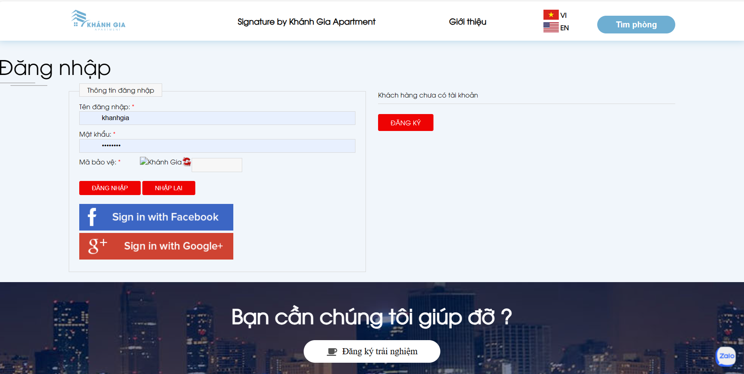

### **Home page**

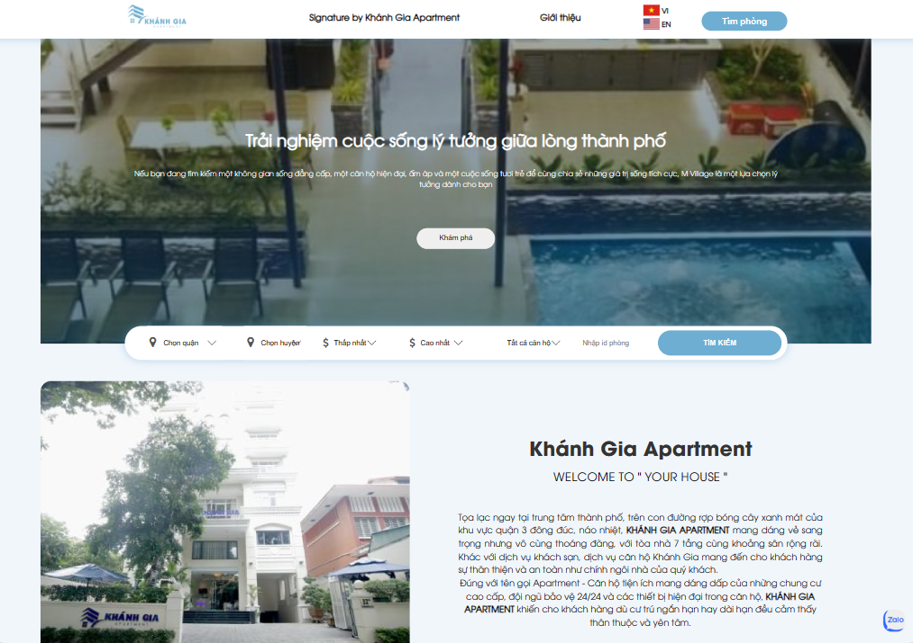

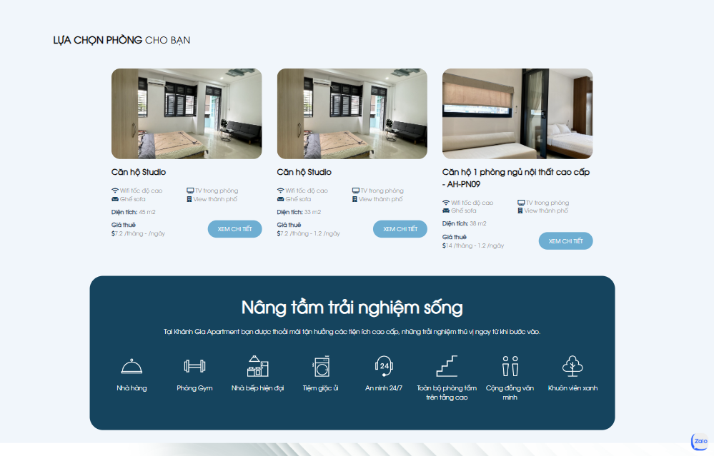

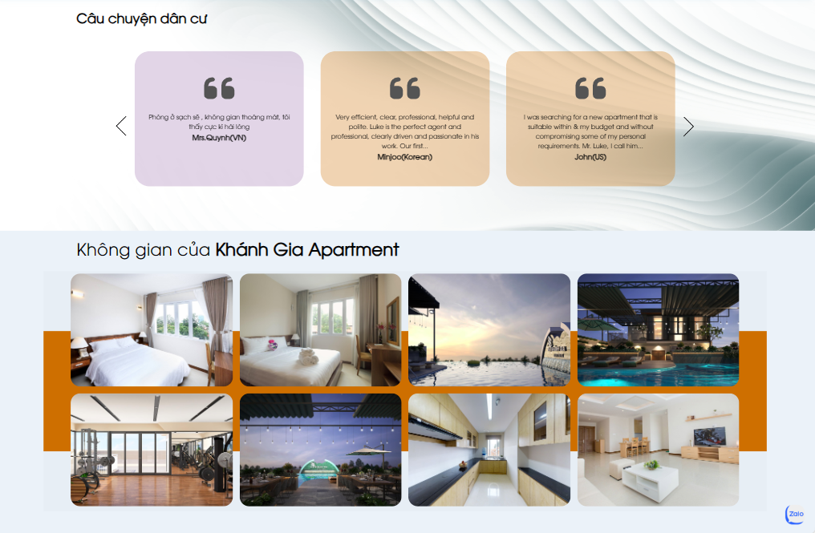

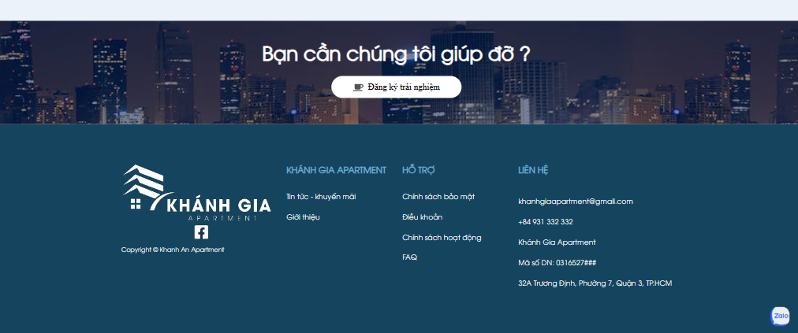

### **Apartment information page**

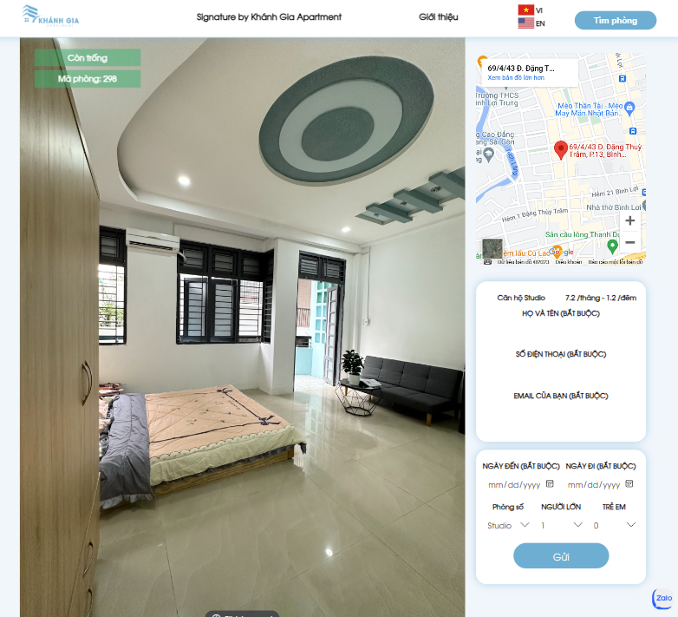

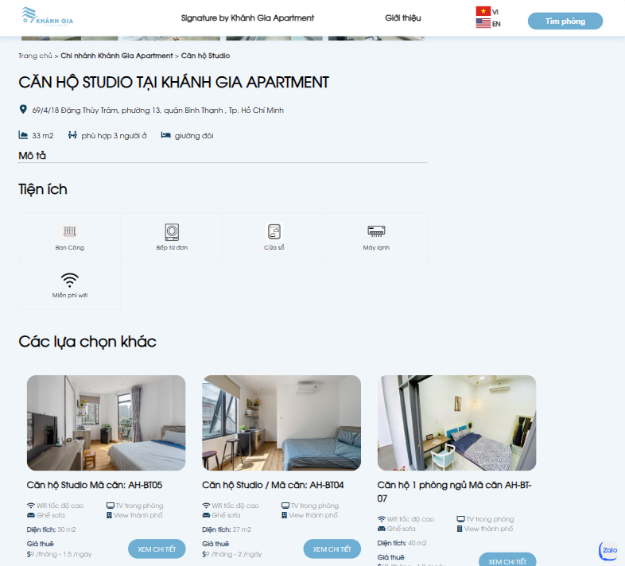

### **Booking apartment page**

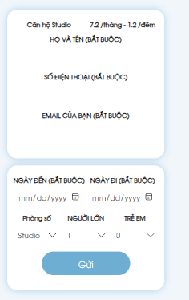

### **Admin interface**

#### Invoice management page

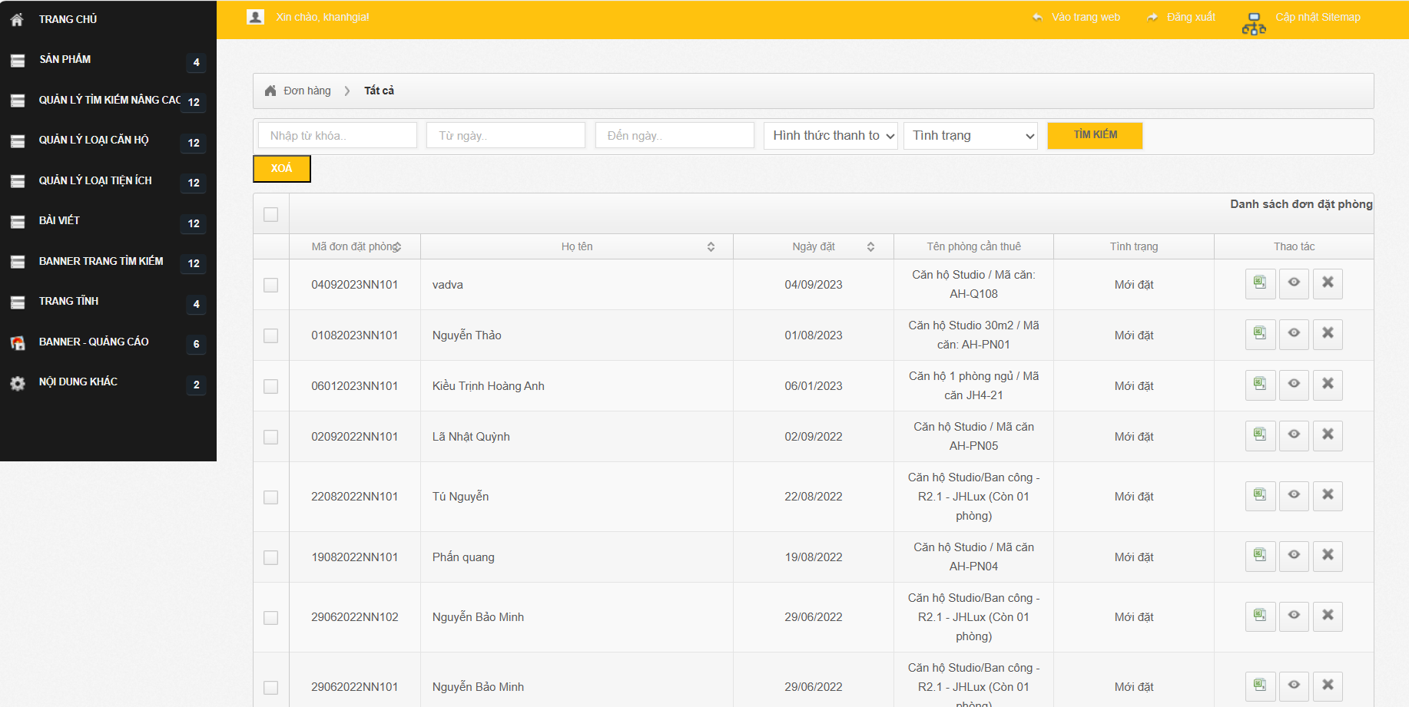

#### Apartment management page

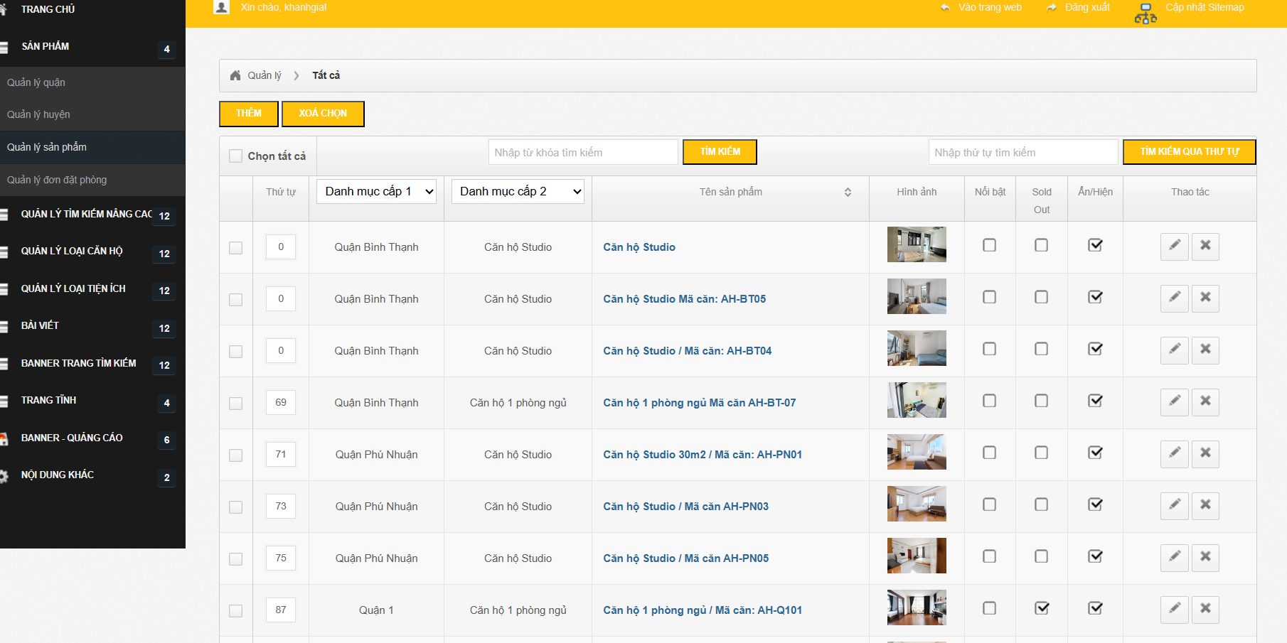

#### Feedback management page

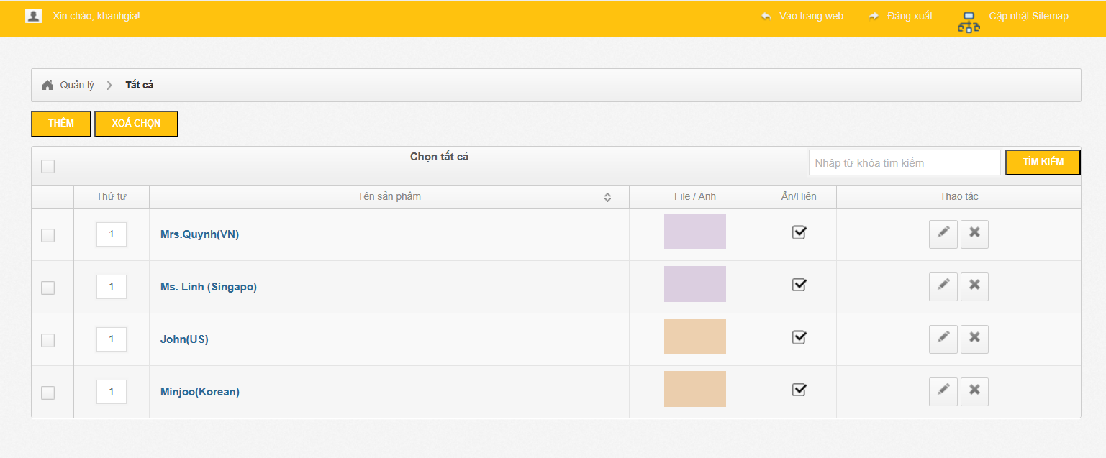

# **Chapter 5: CONCLUSION**



## **Project achievement**

During the implementation of the project, our group has accumulated knowledge related to many subjects, especially the subject of information system analysis and design, thereby achieving remarkable results as follows:

* Booking apartment.
* Sign in/Sign up.
* Give feedback.
* Customer can update their profile and cacel apartment booking invoice.
* Manage employees.
* Manage customers.
* Manage apartments.
* Manage invoices.
* Manage feedback.

## **Limitations**

Due to the limited time of the study, the study has the following limitations:

* Users can not use payment method online.
* Analyse the statistics of invoice by month/year.

## **Development direction**

To perfect the travel booking website, our group gives the following development directions for the current software as follow:

* Analyse the statistics of invoice.
* Adding a payment method online.
* Adding more accompanied services when booking the apartment.